**Module 4 Activity 4: Create Requirements and transfer the requirement to Entity Design using UML**

Saurabh Kale

IFT 458/554: Middleware Programming & Database Security

Dinesh Sthapit

Oct 8th, 2023

**Part 1: Requirements: ** Design**

*Config.env-*

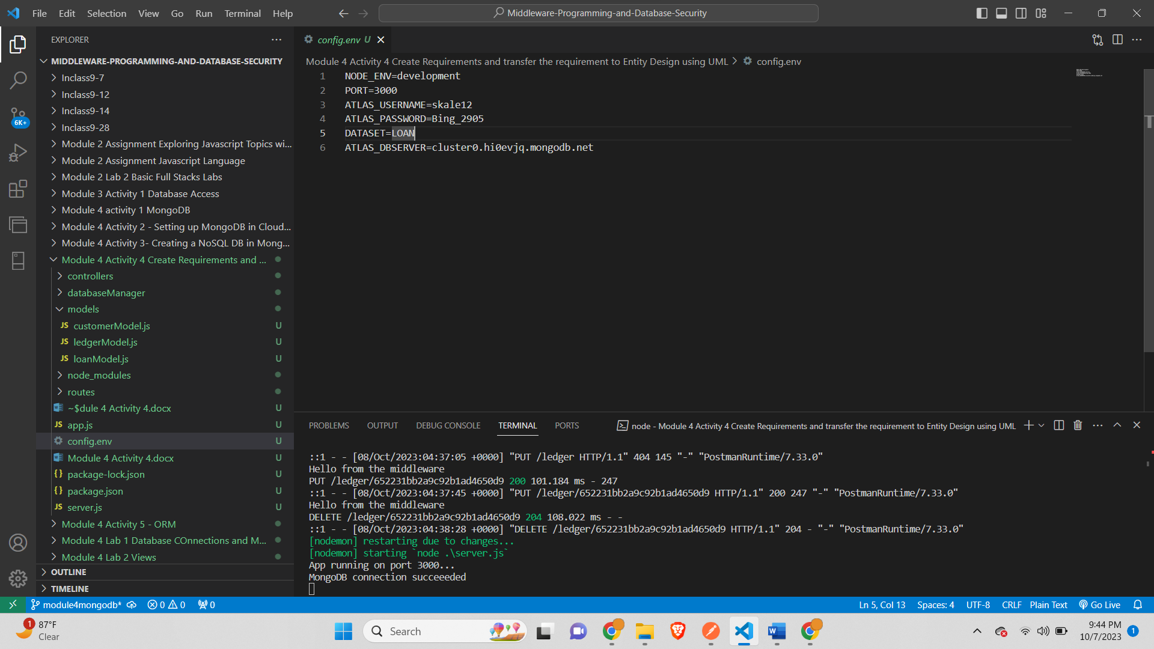



*Server.js-*

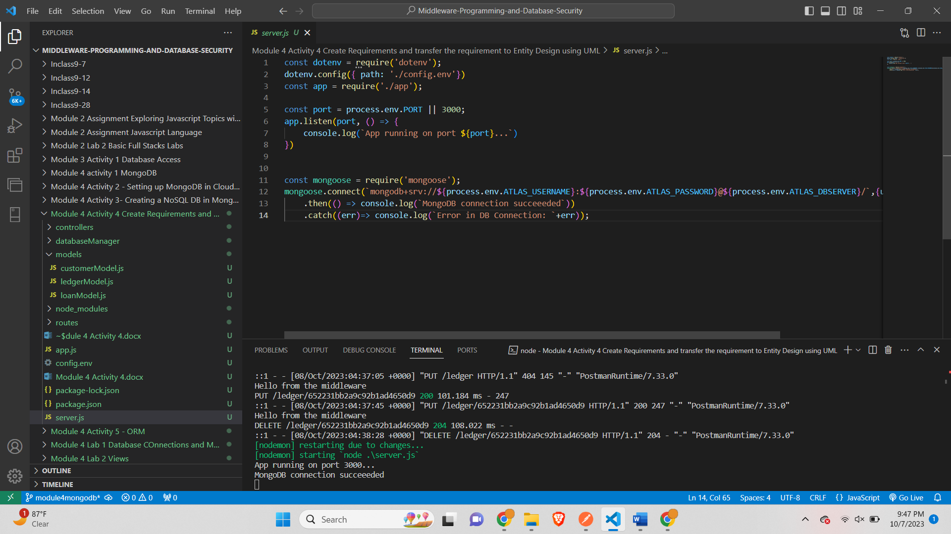

*App.js-*

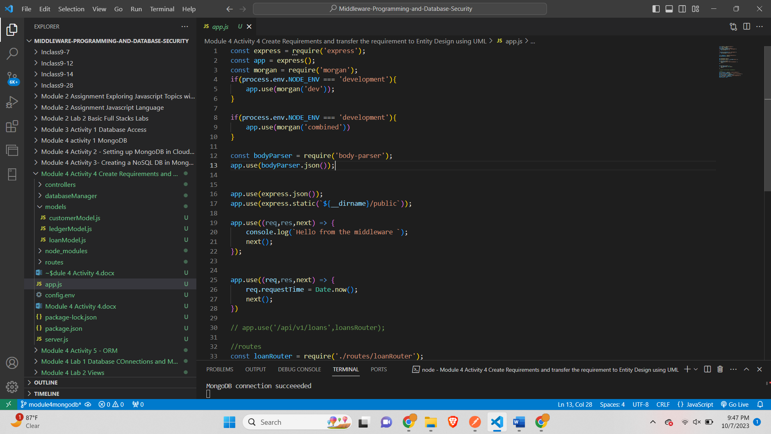

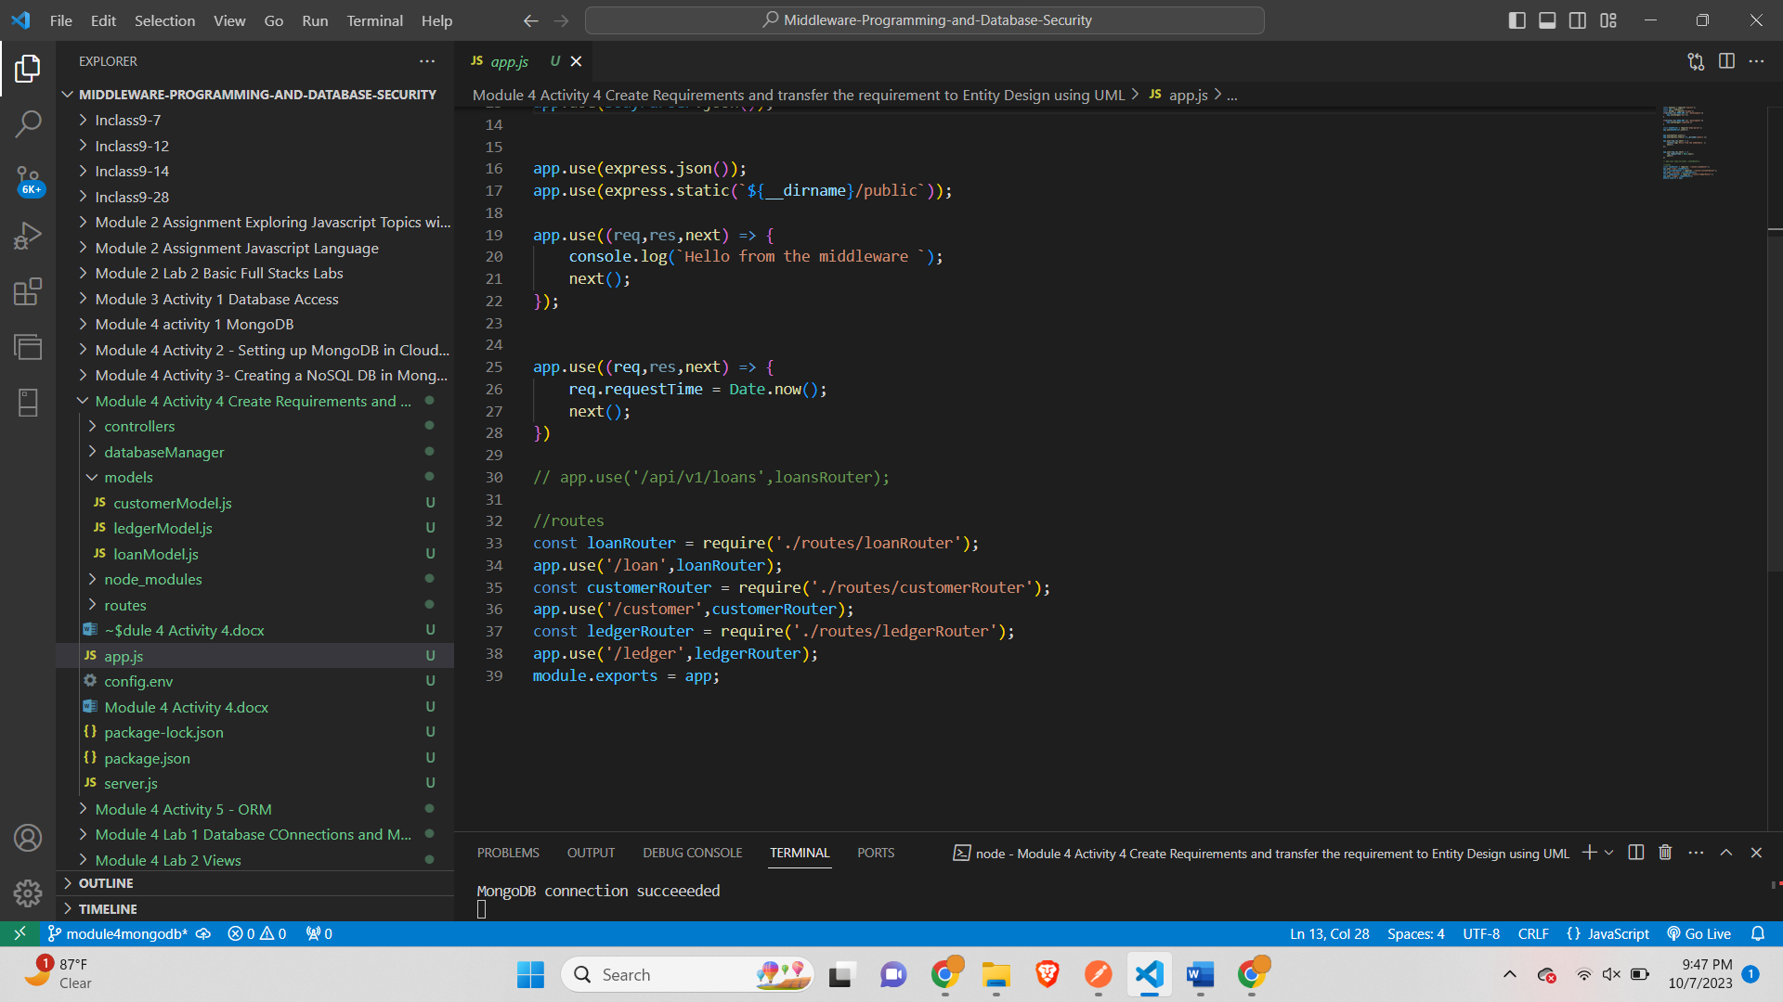

*customerRouter.js-*

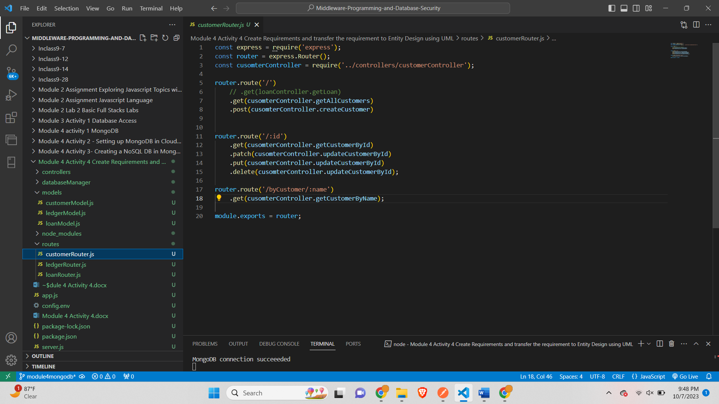

*ledgerRouter.js-*

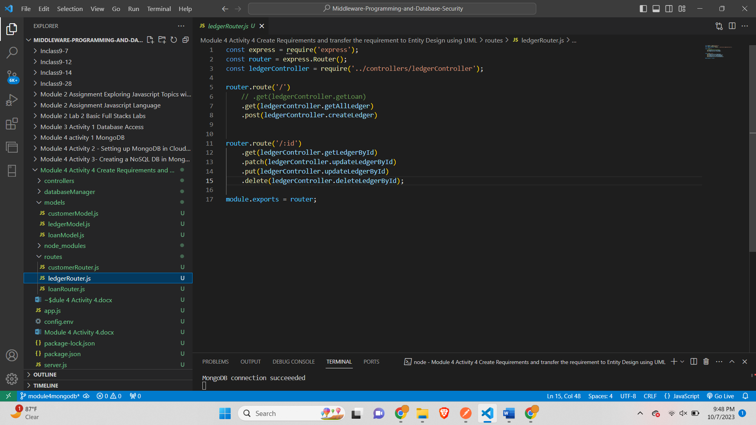

*loanRouter.js-*

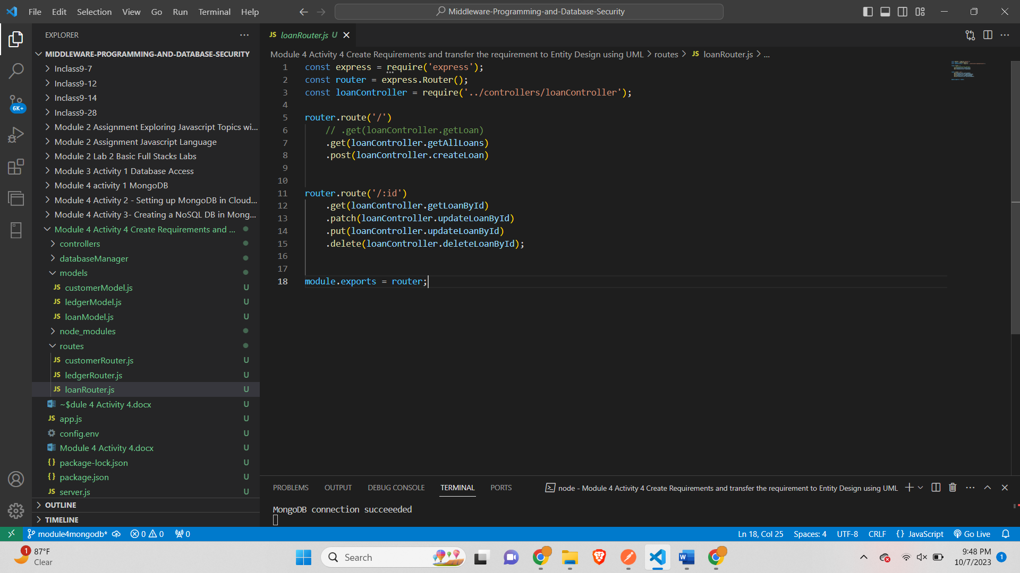

*customerController.js-*

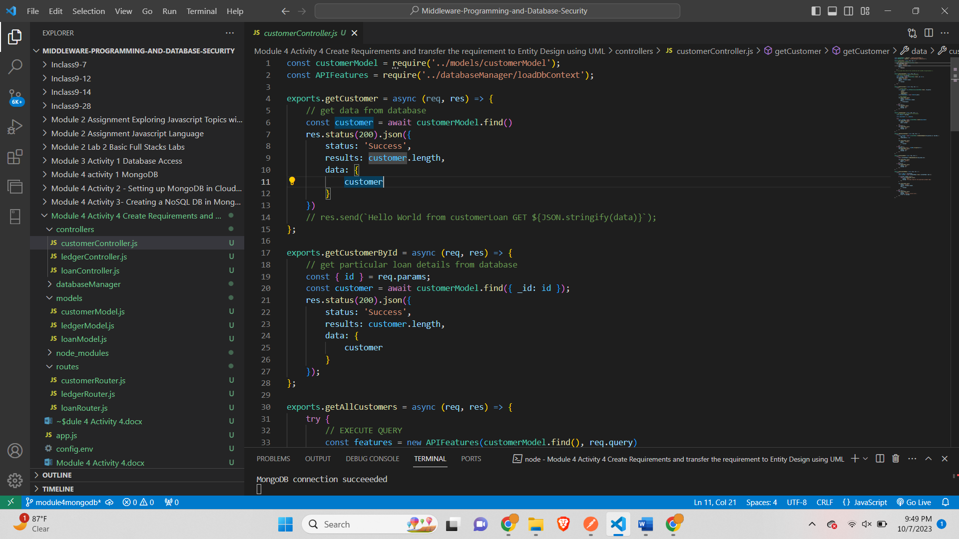

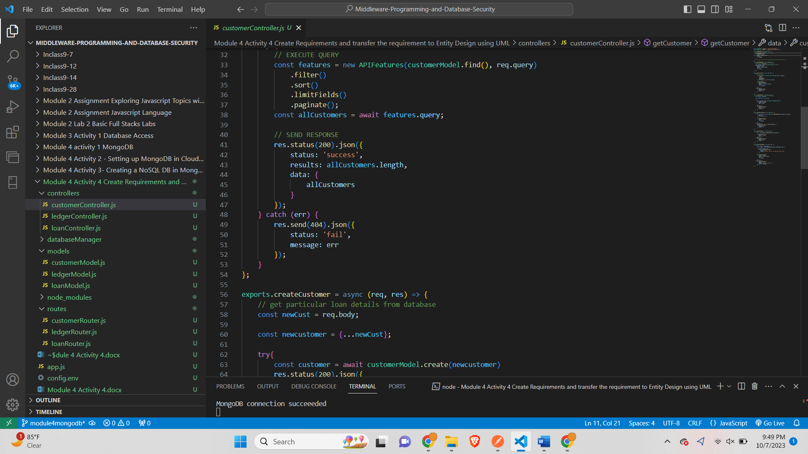

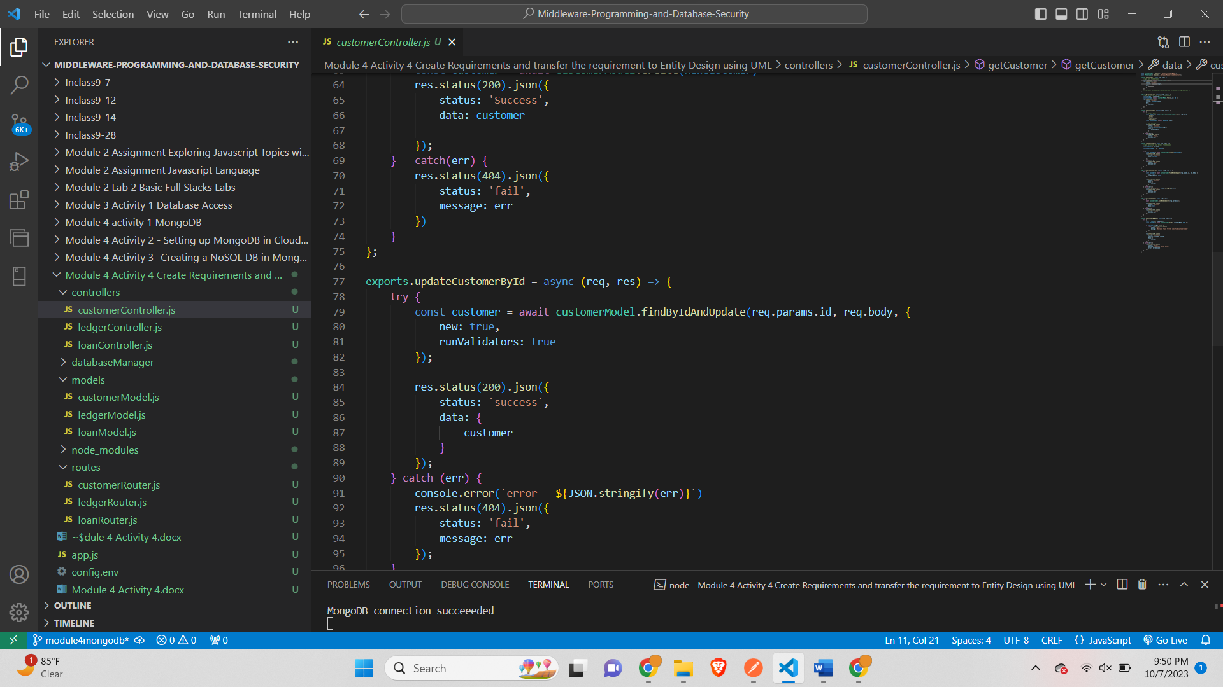

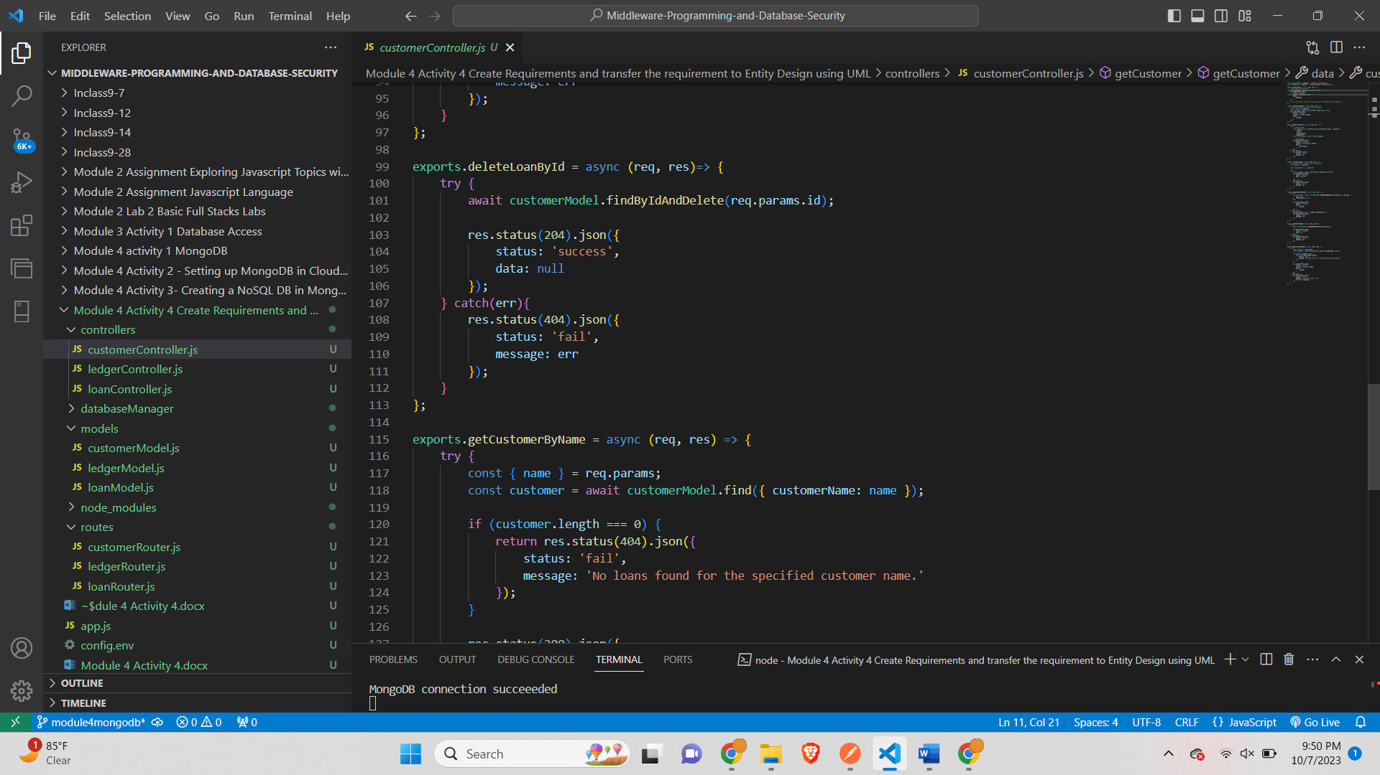

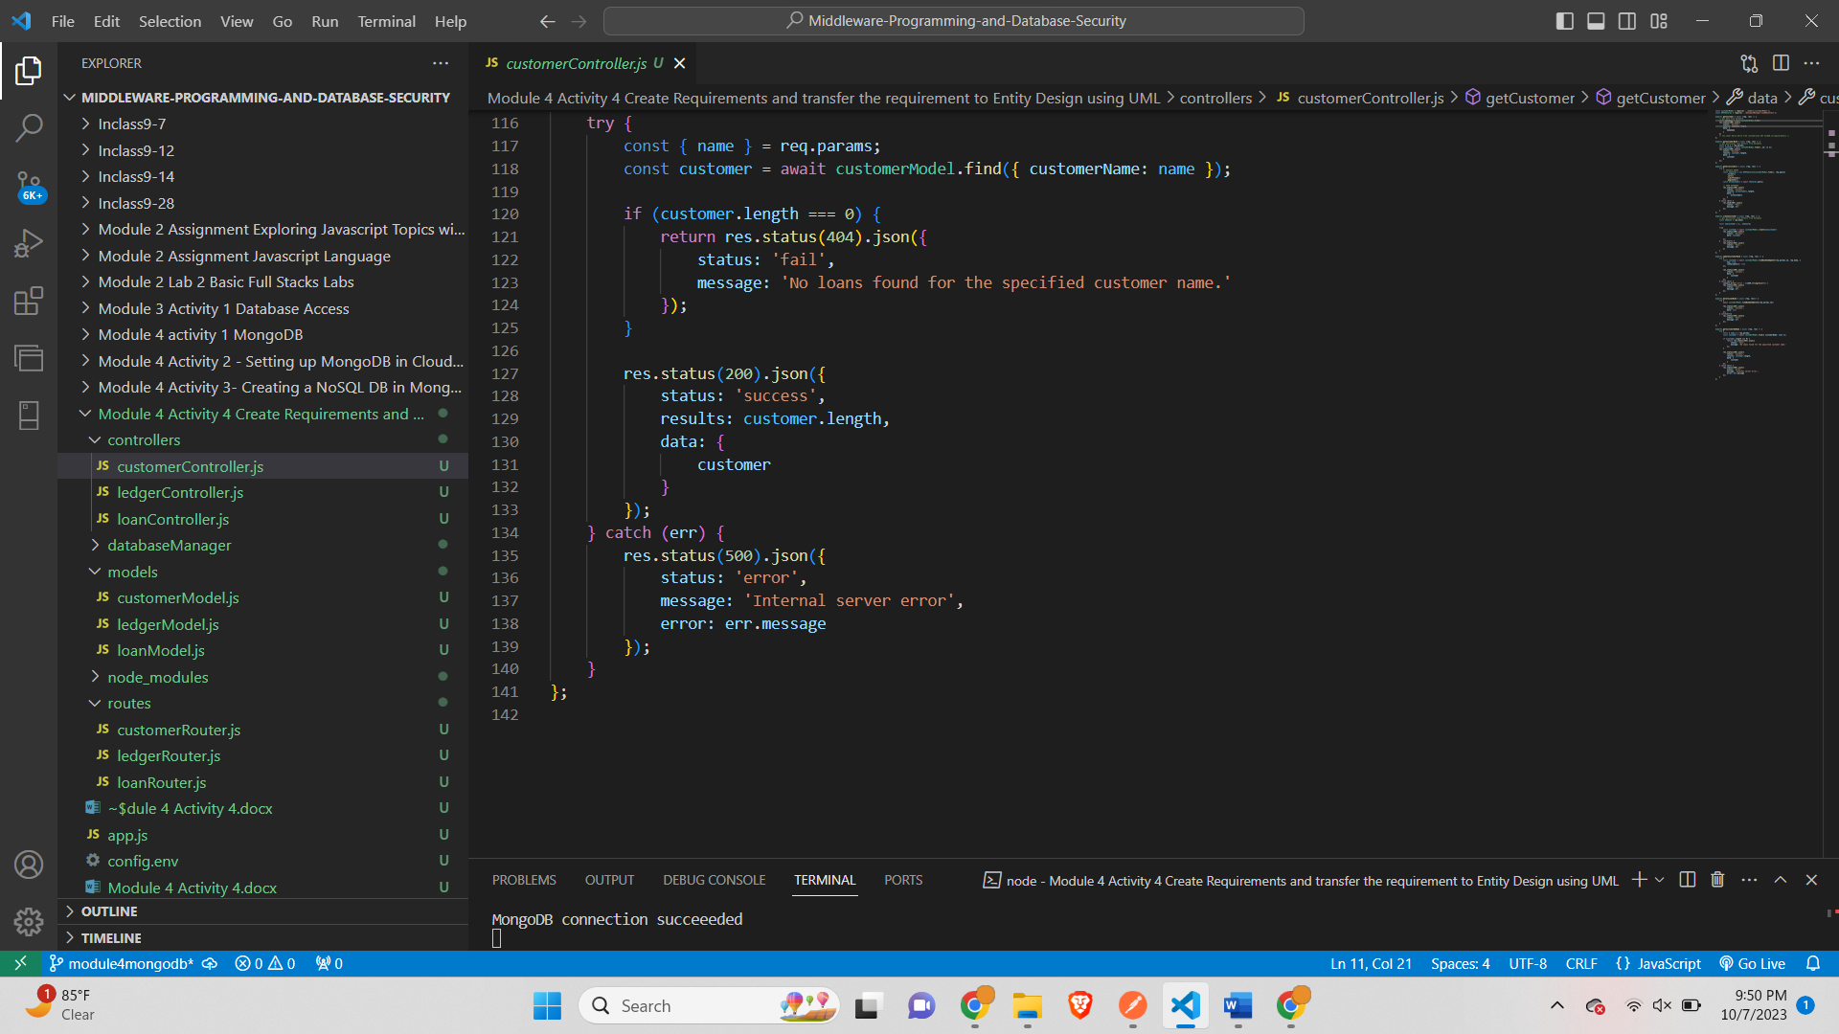

*ledgerController.js-*

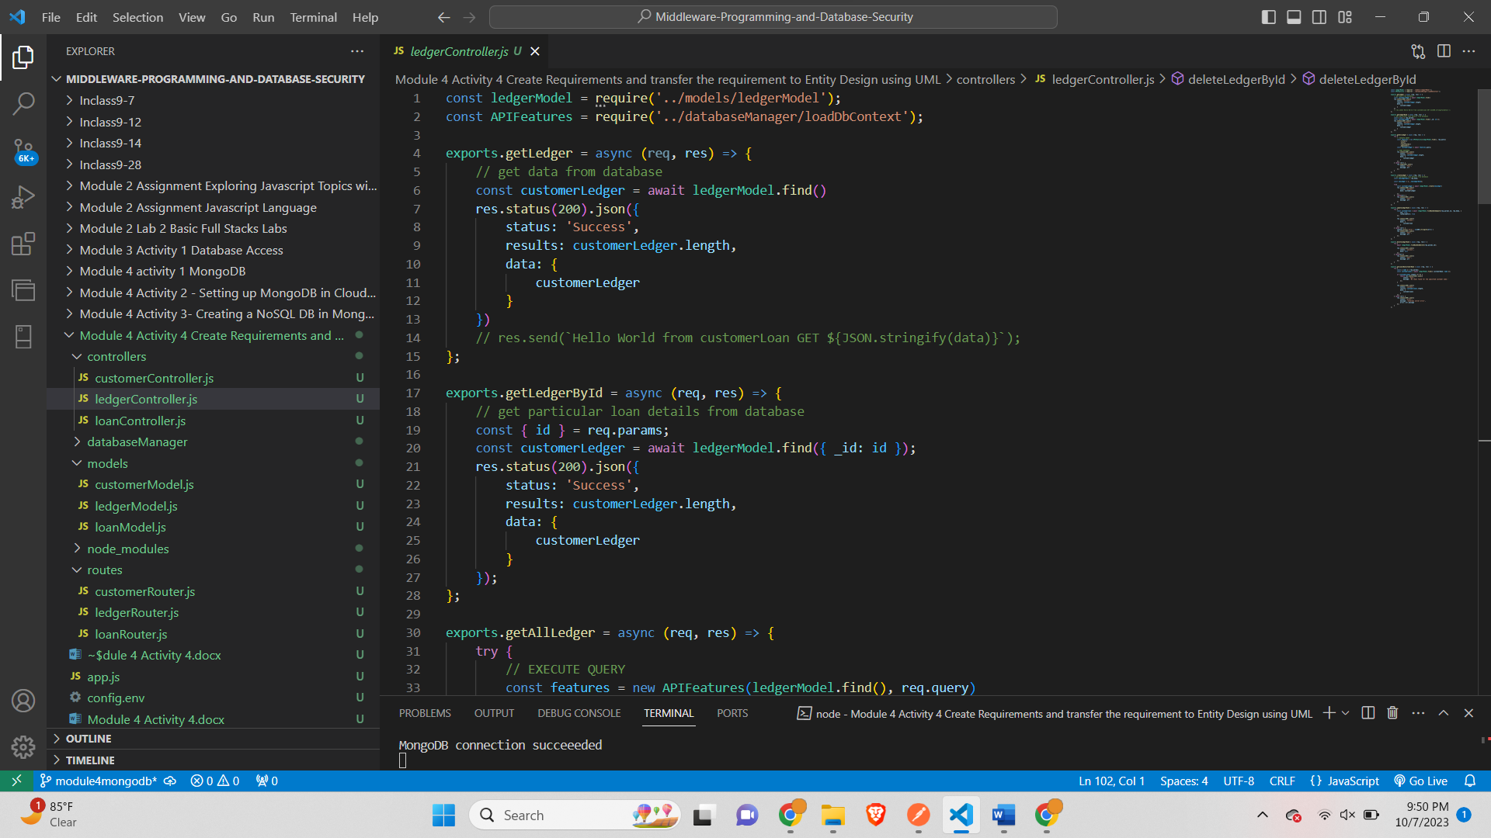

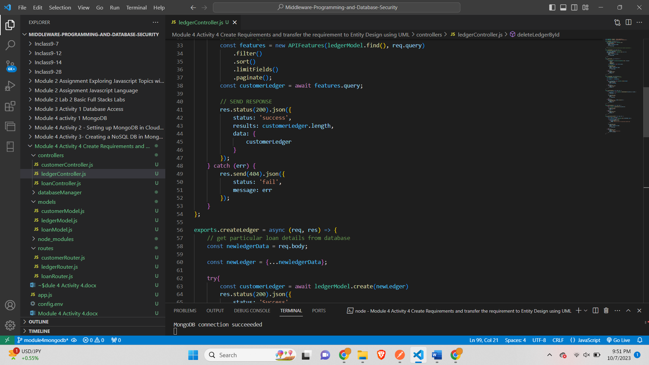

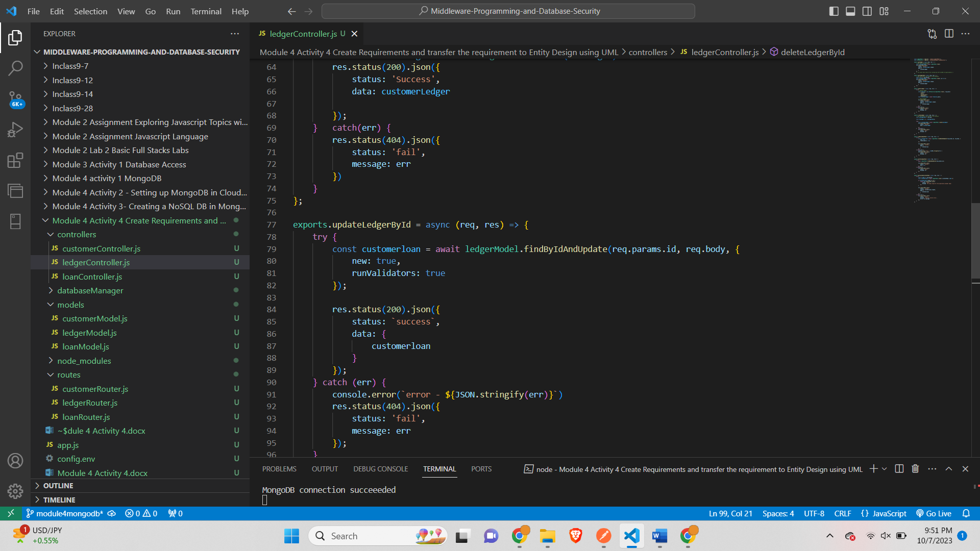

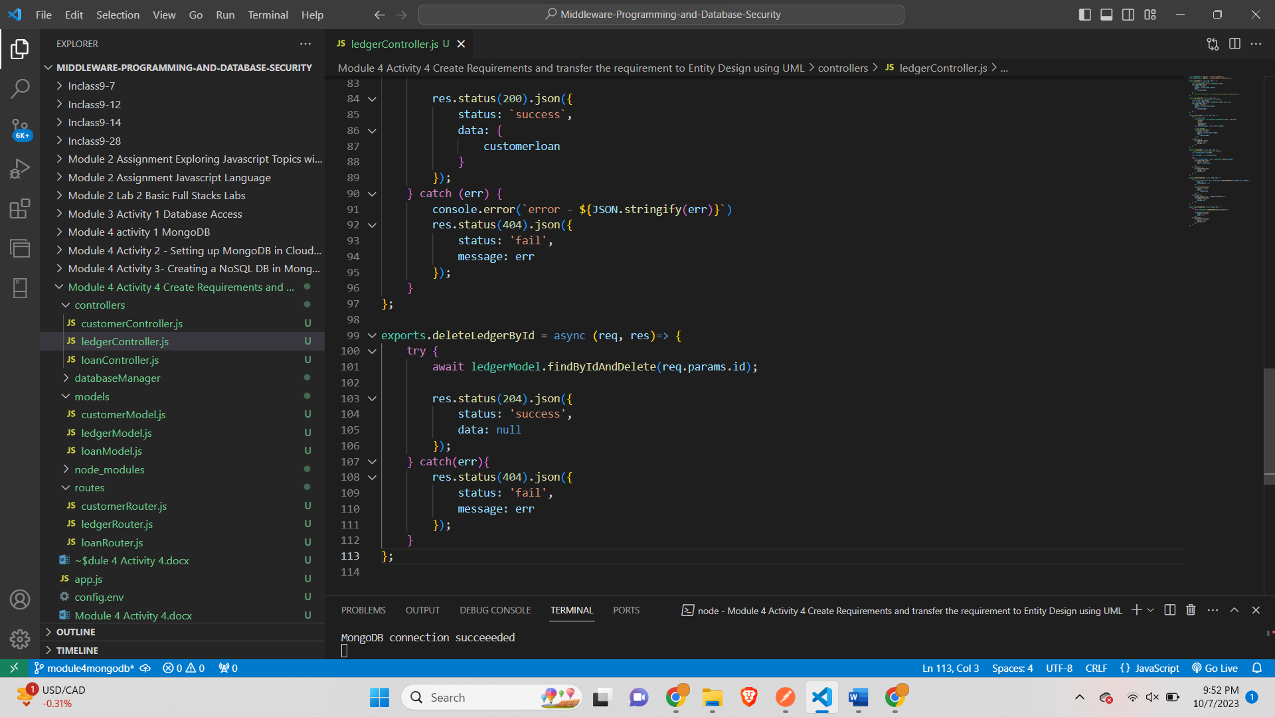

*loanController.js-*

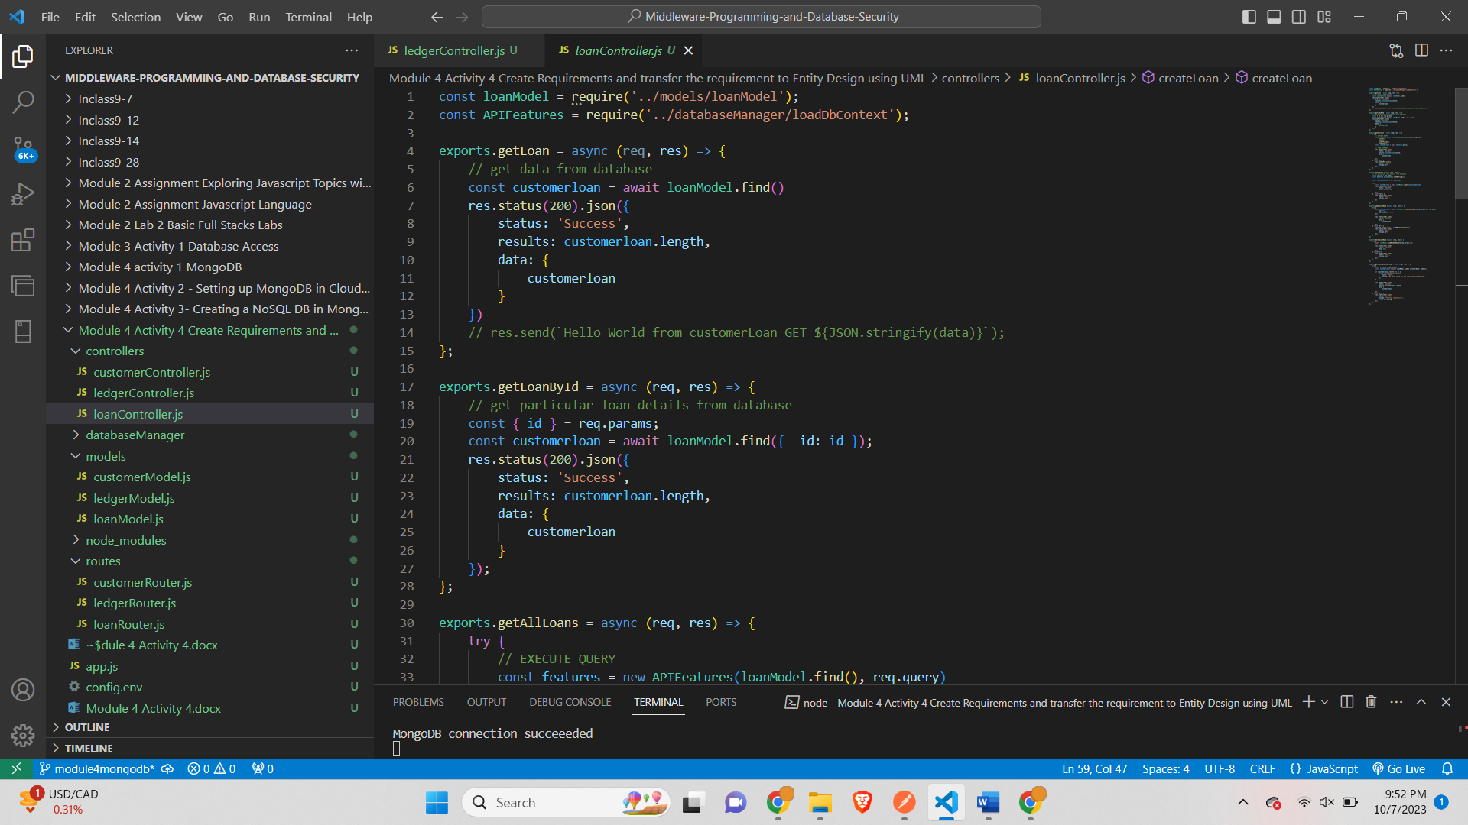

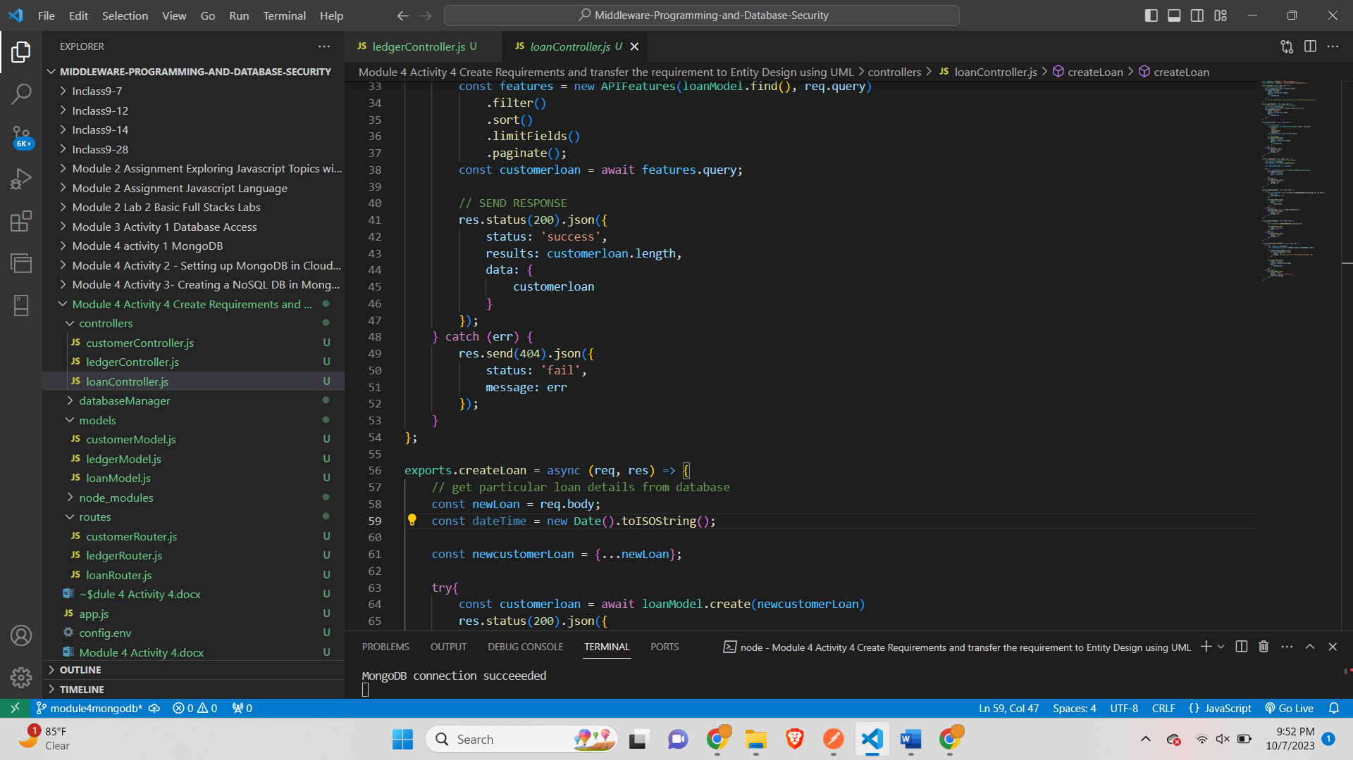

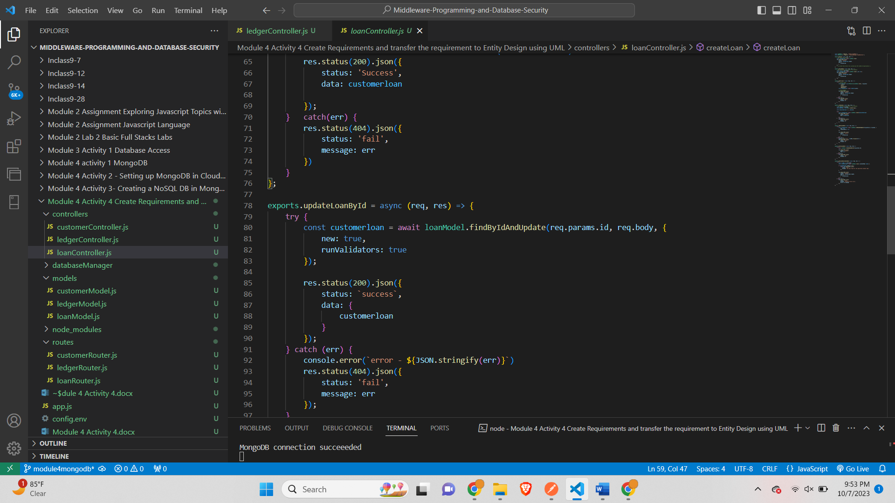

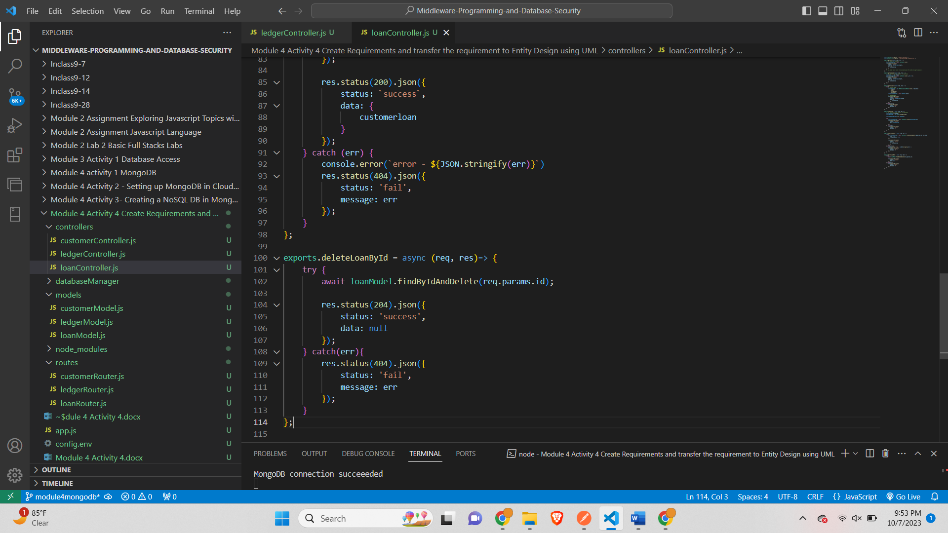

*customerModel.js-*

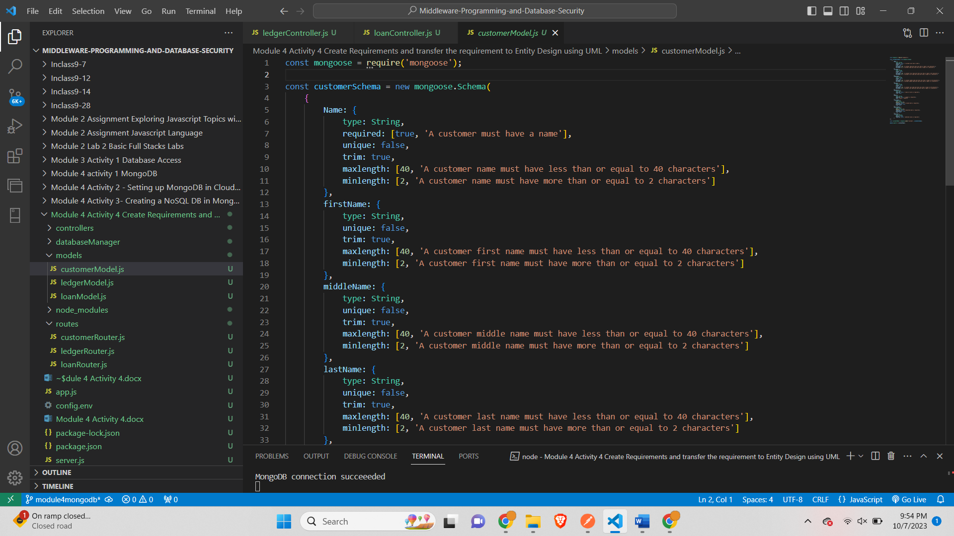

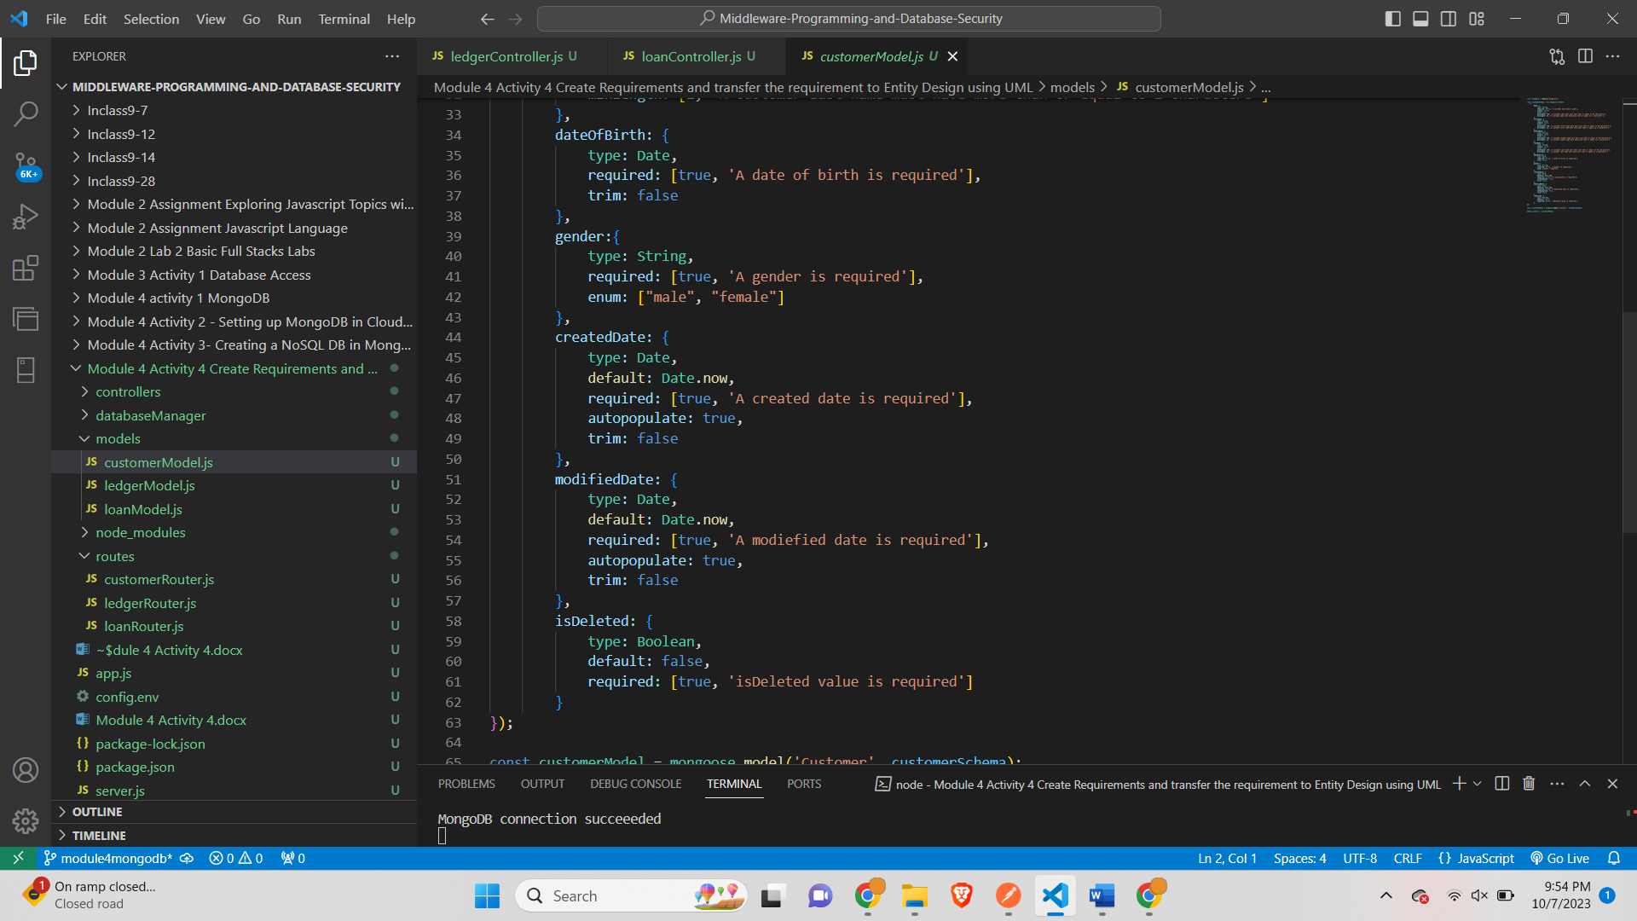

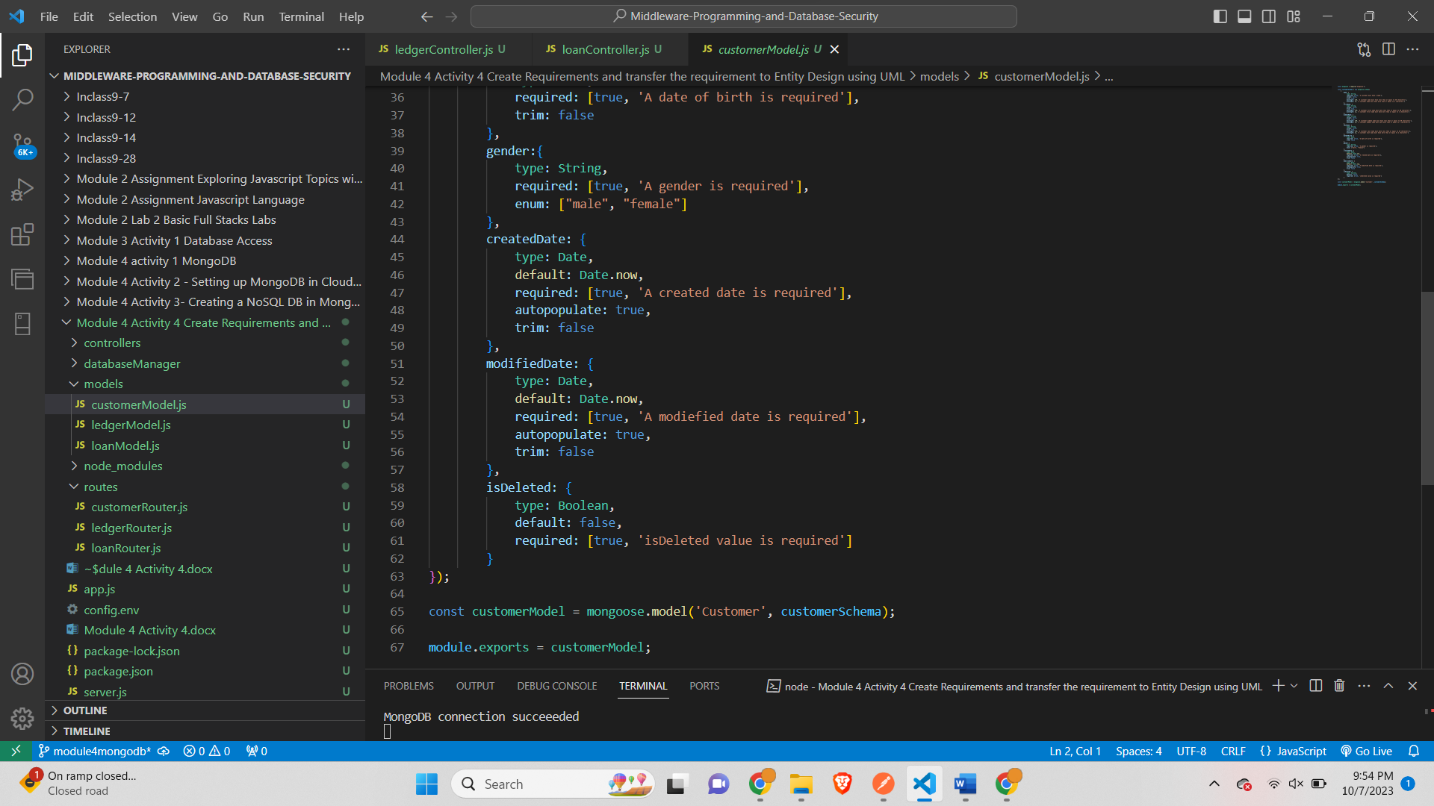

*ledgerModel.js-*

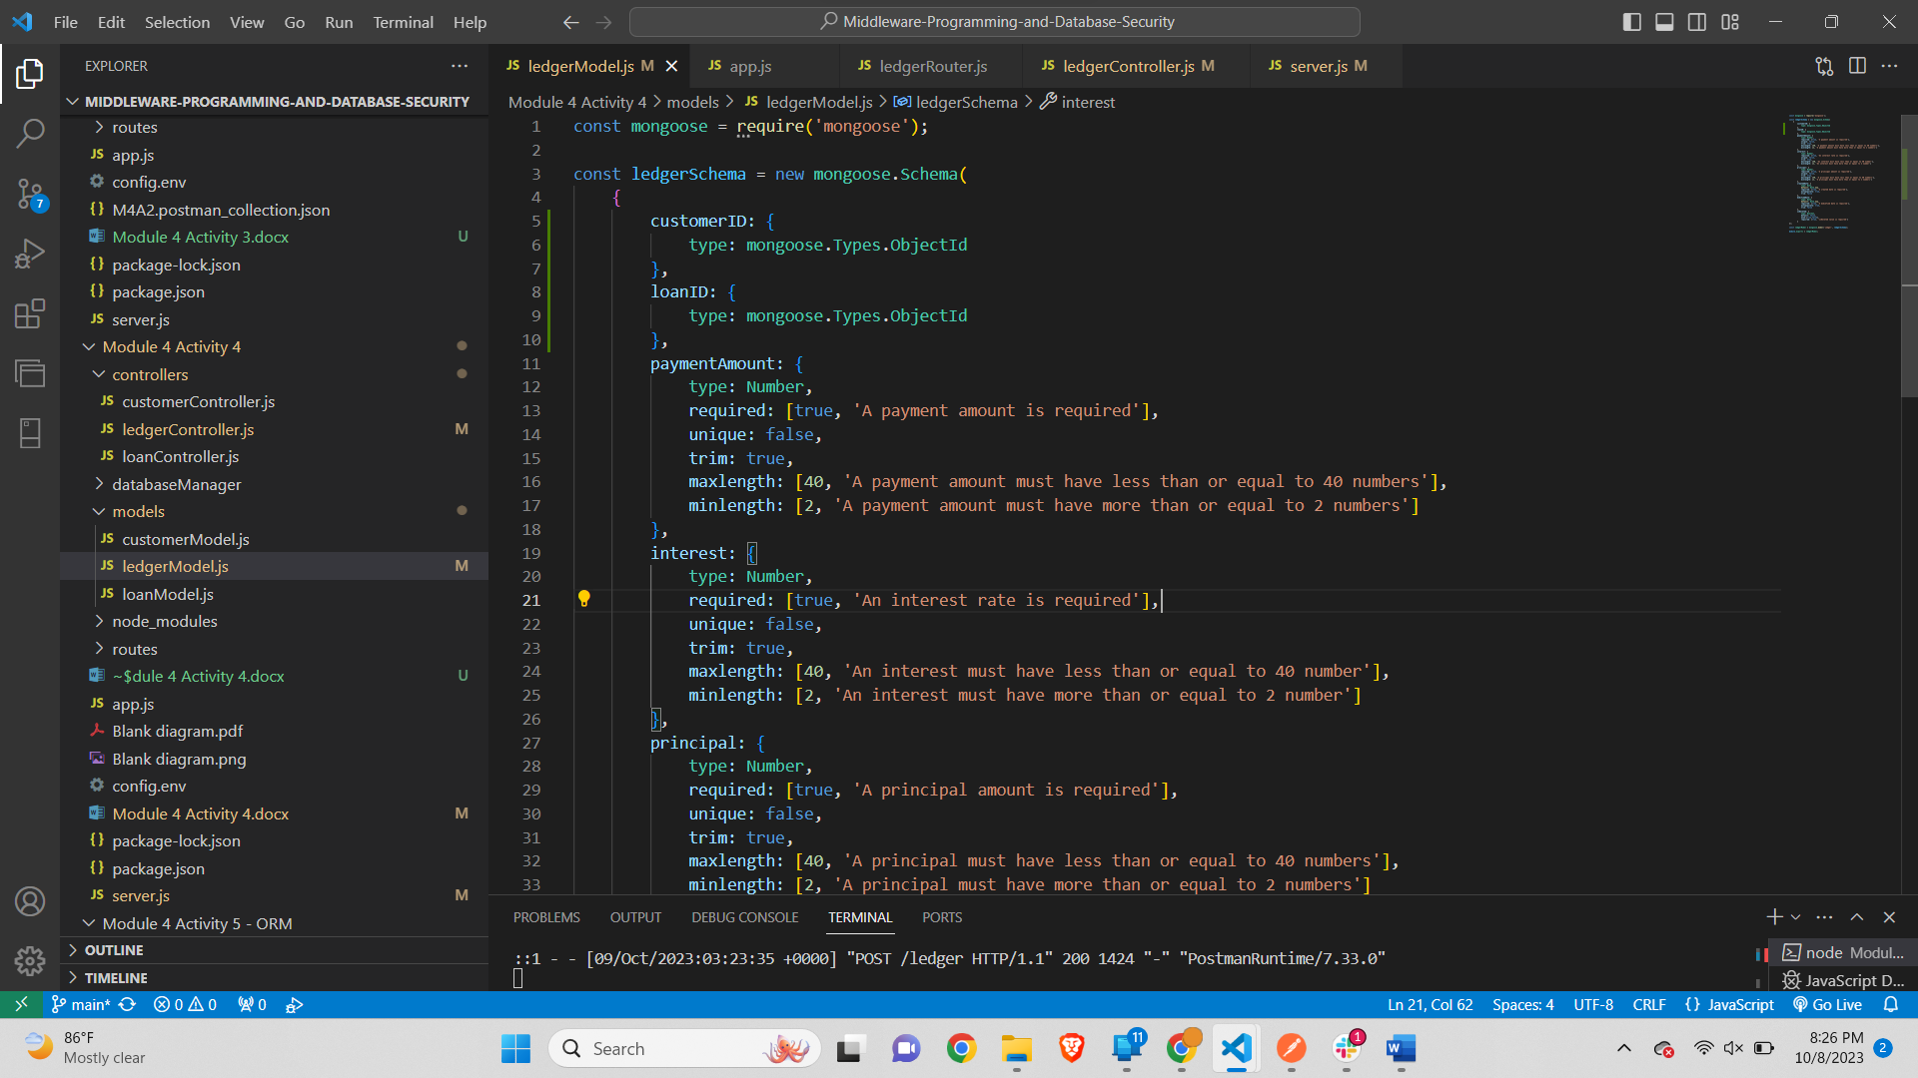

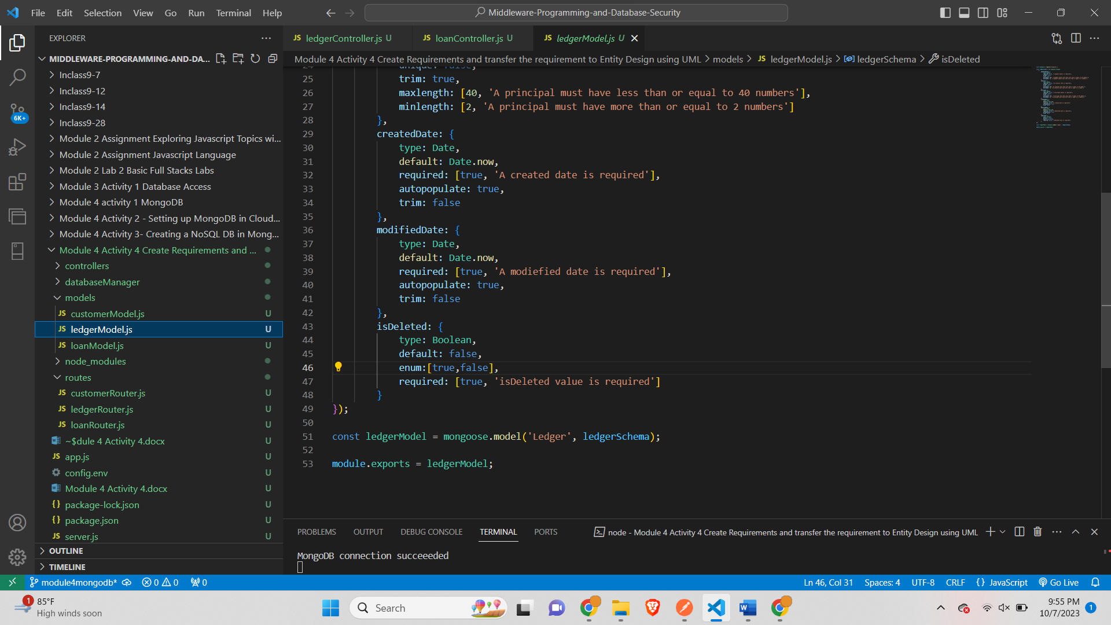

*loanModel.js-*

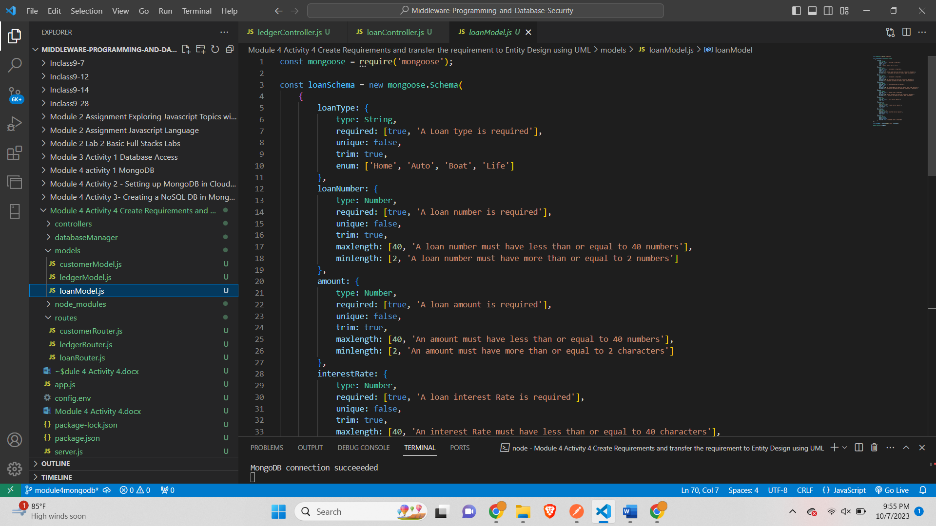

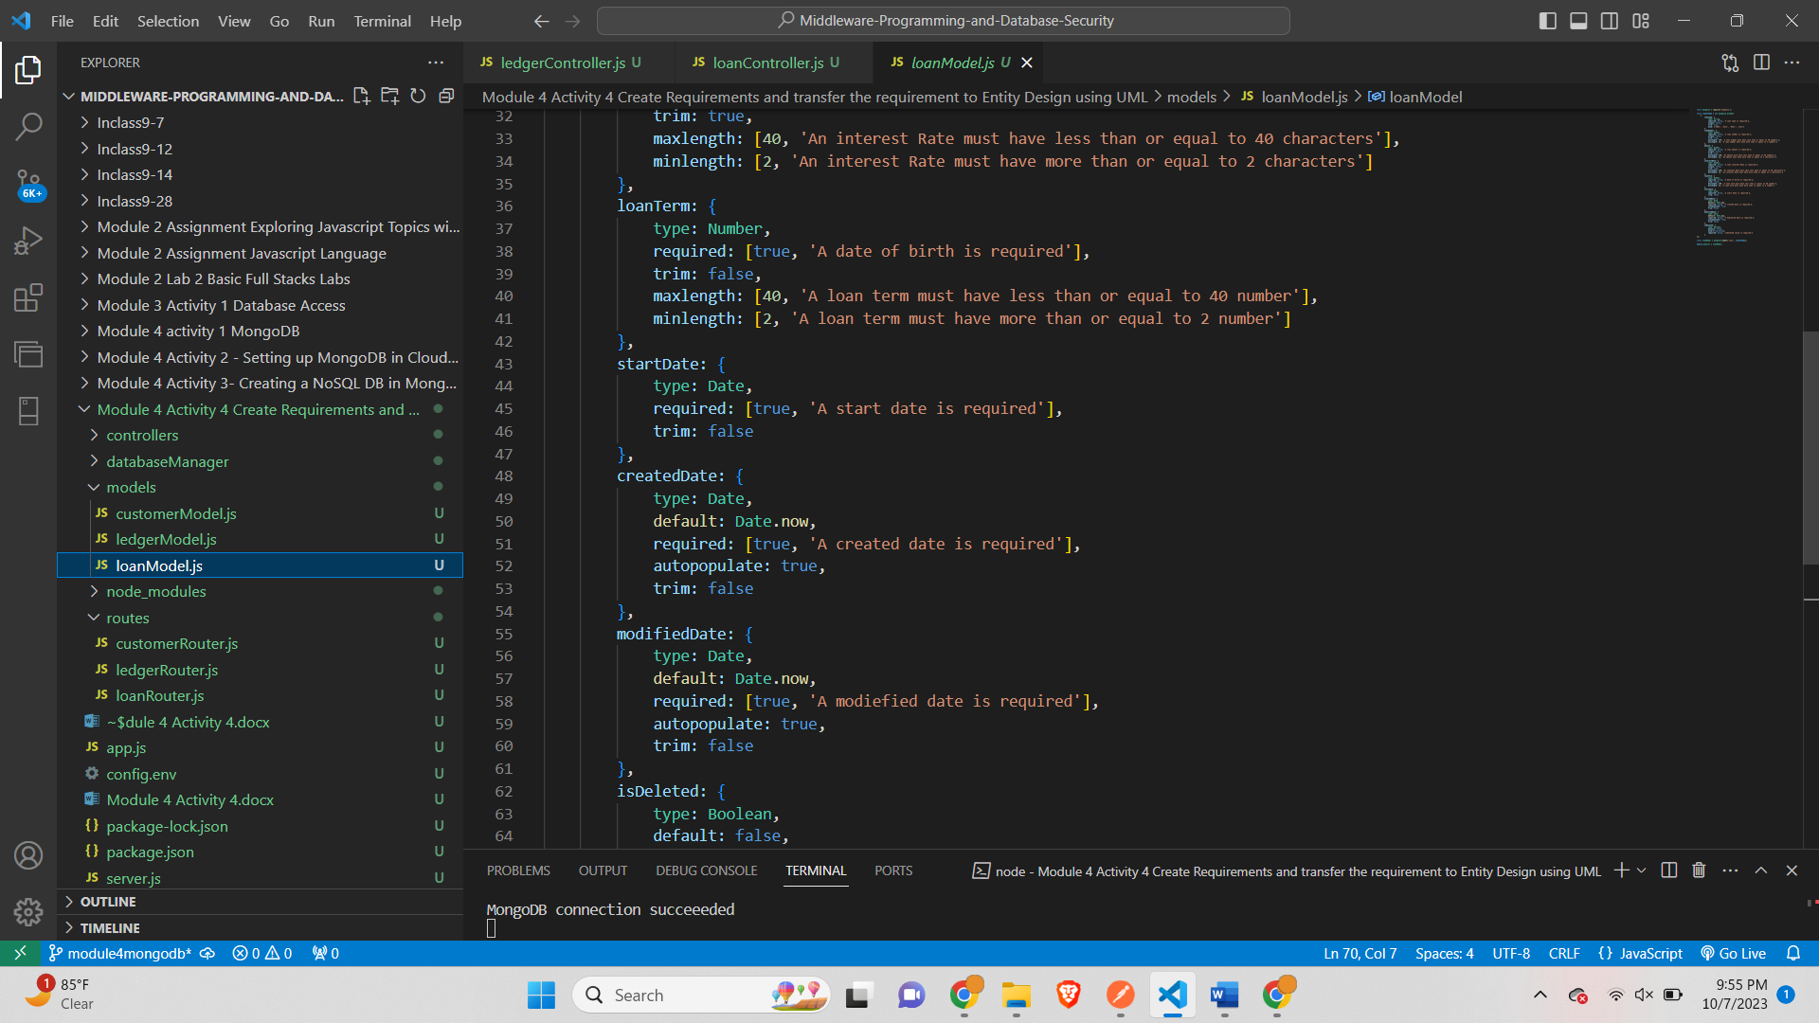

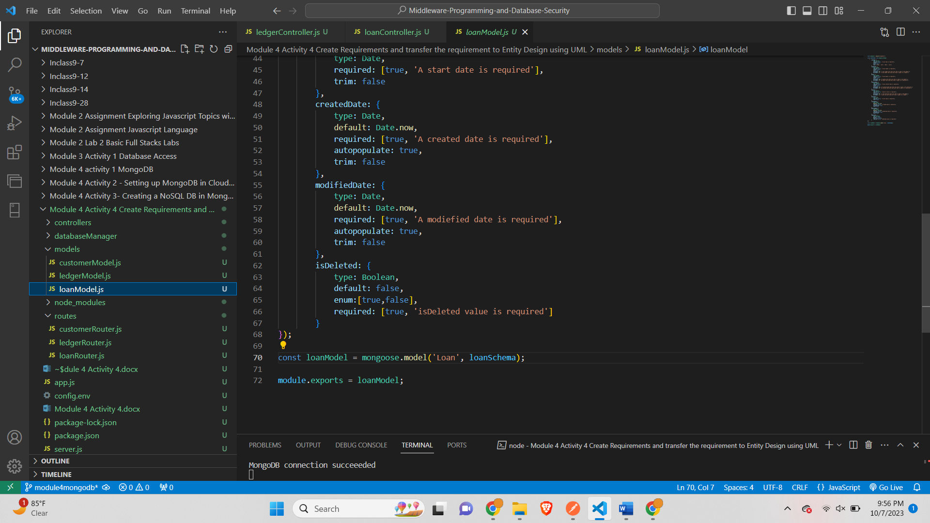

*ER Diagram-*

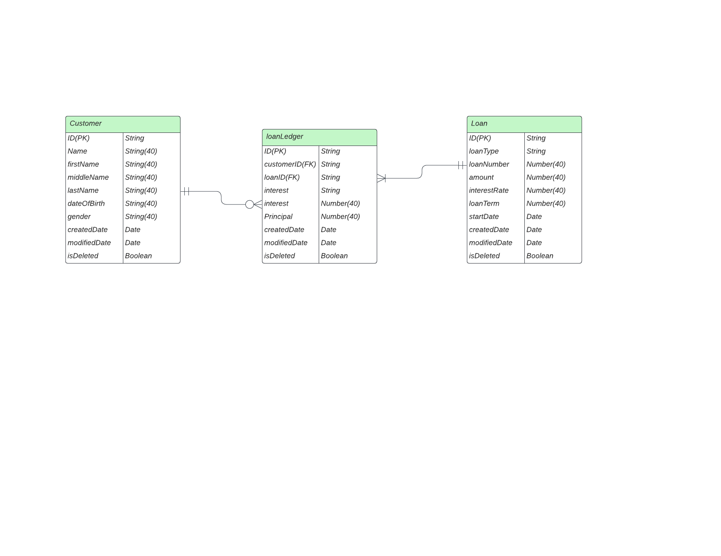

***Part 2: Requirement Storage Design Implementation: (DATABASE)***

*Created Database LOAN-*

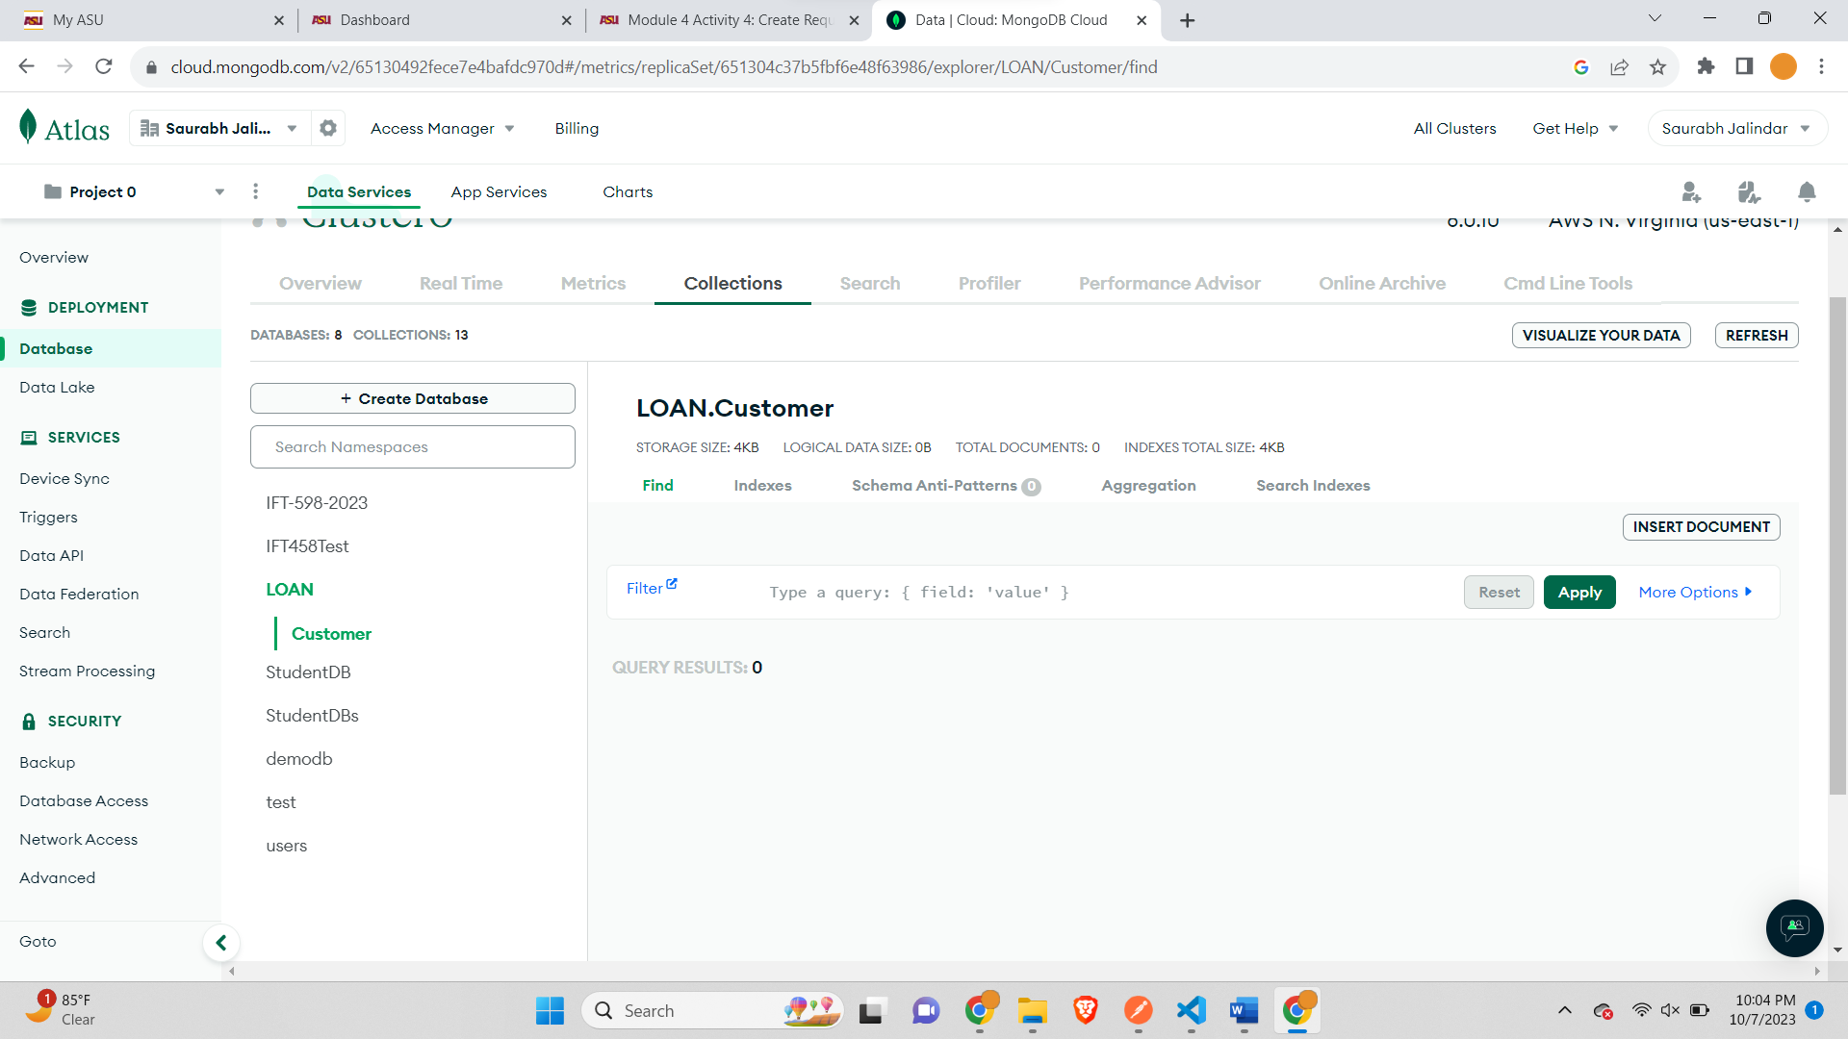

*autoPopulate-*

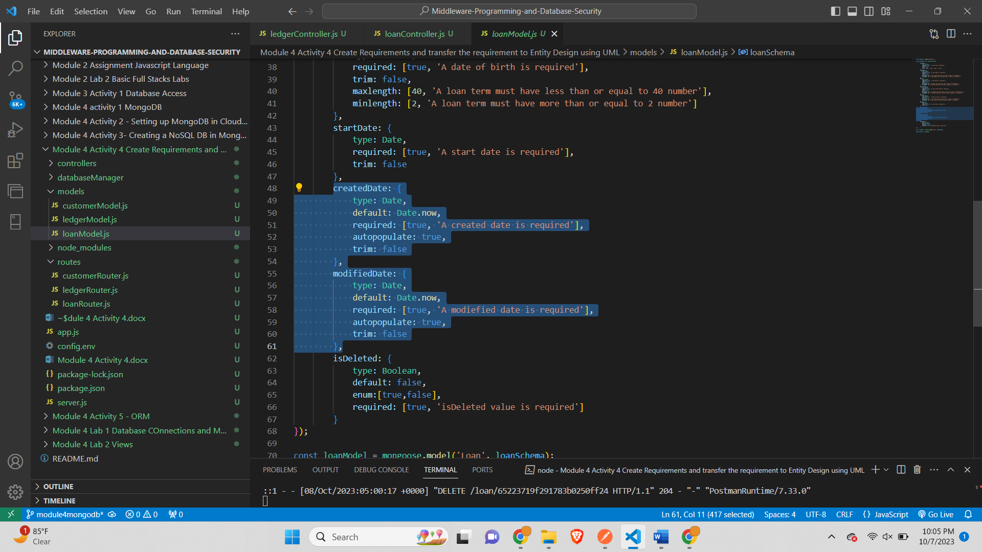

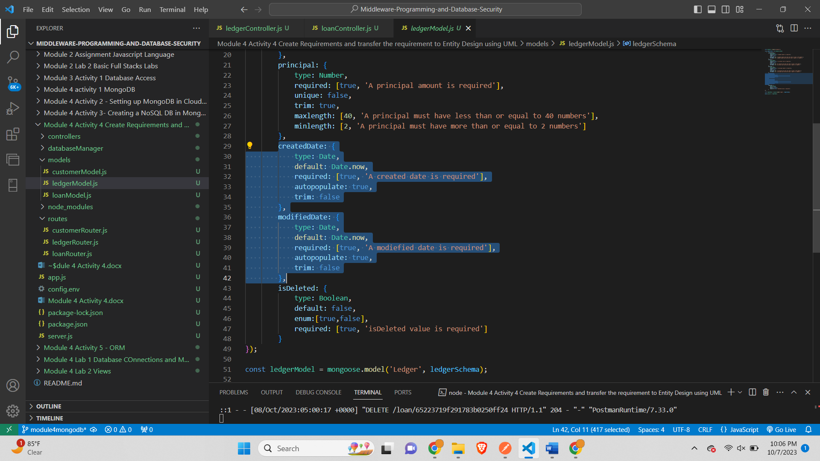

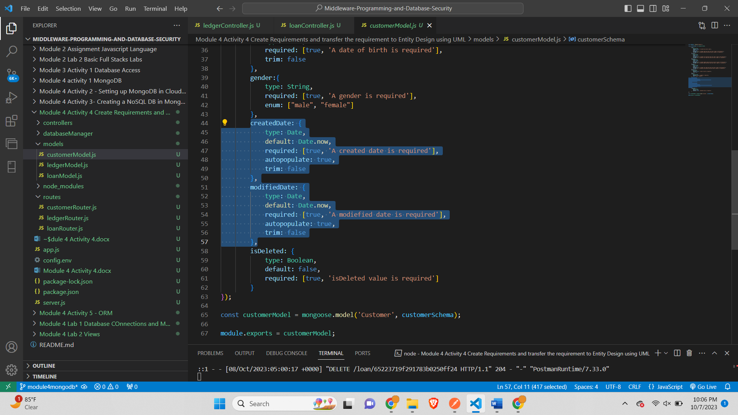

*Insert 10 Customer Records-*

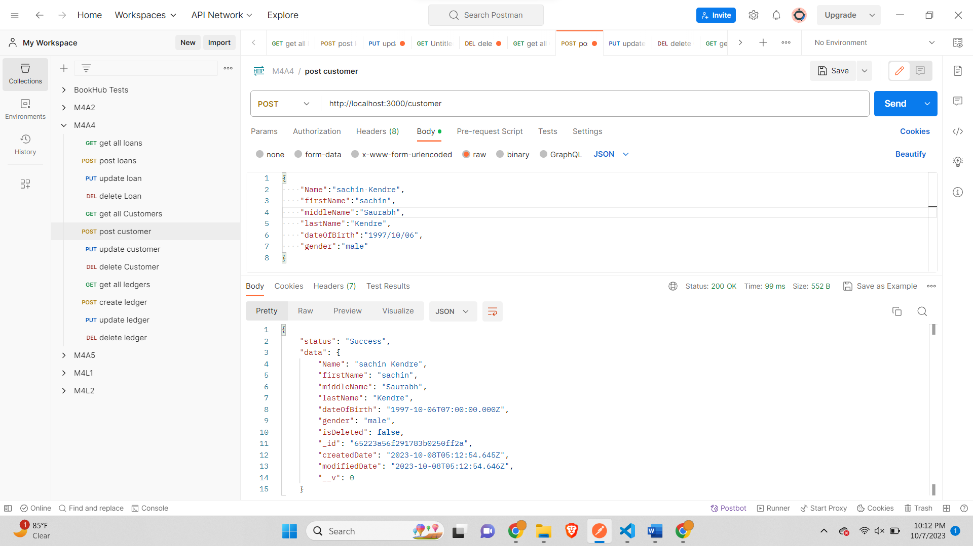

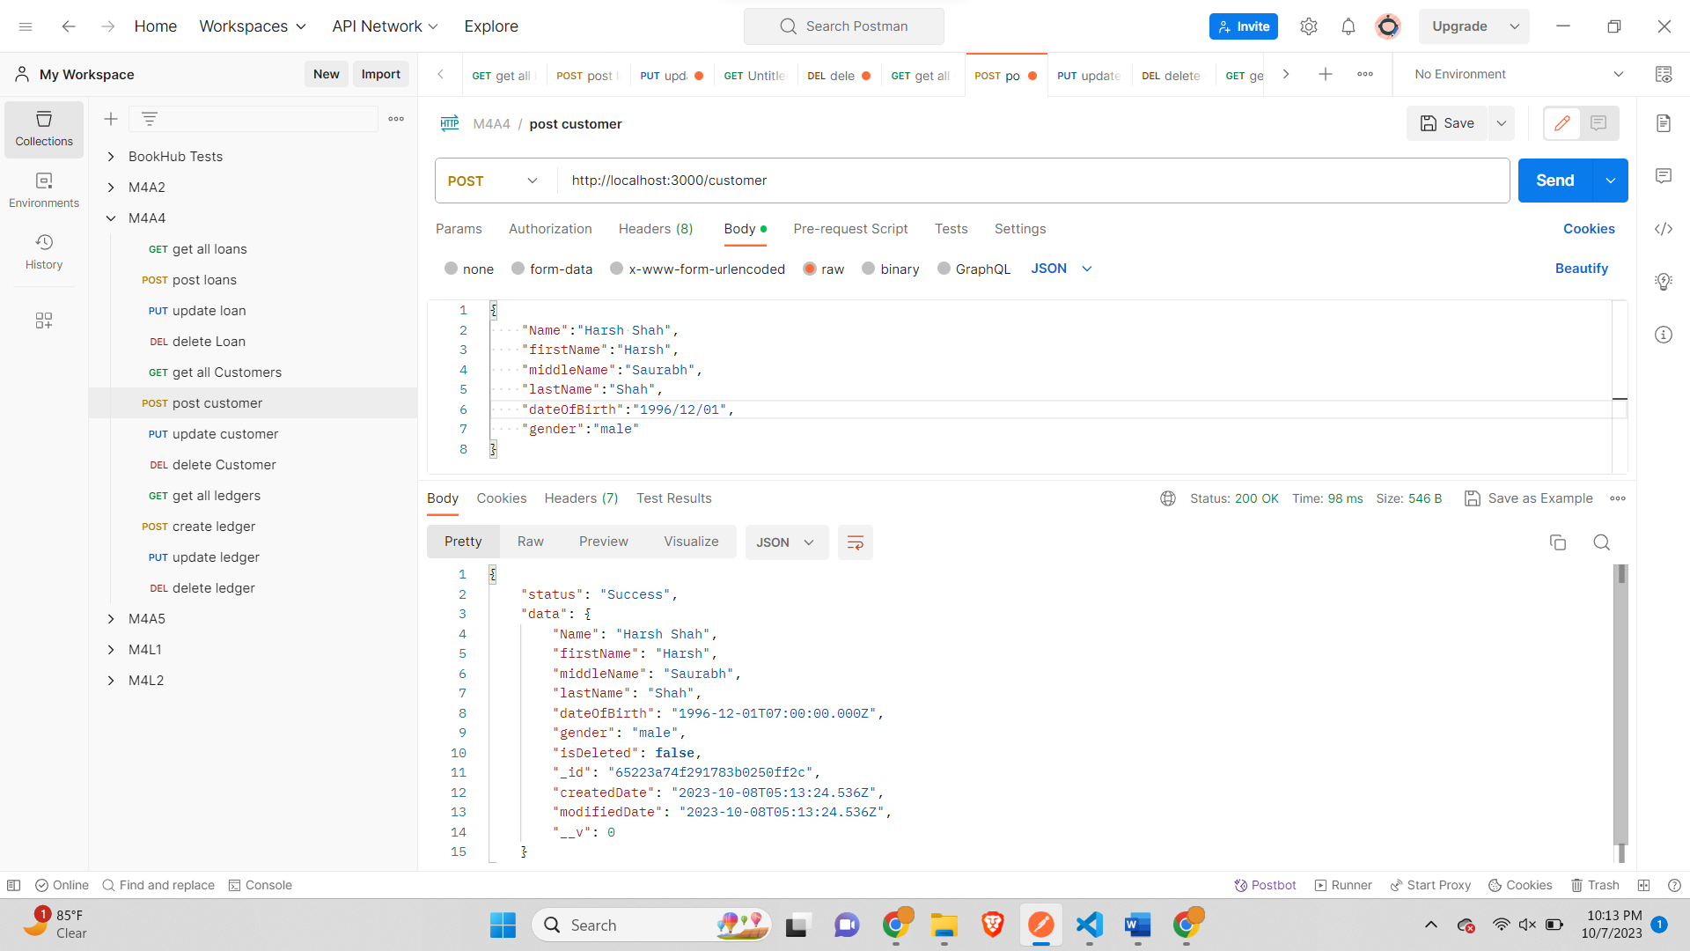

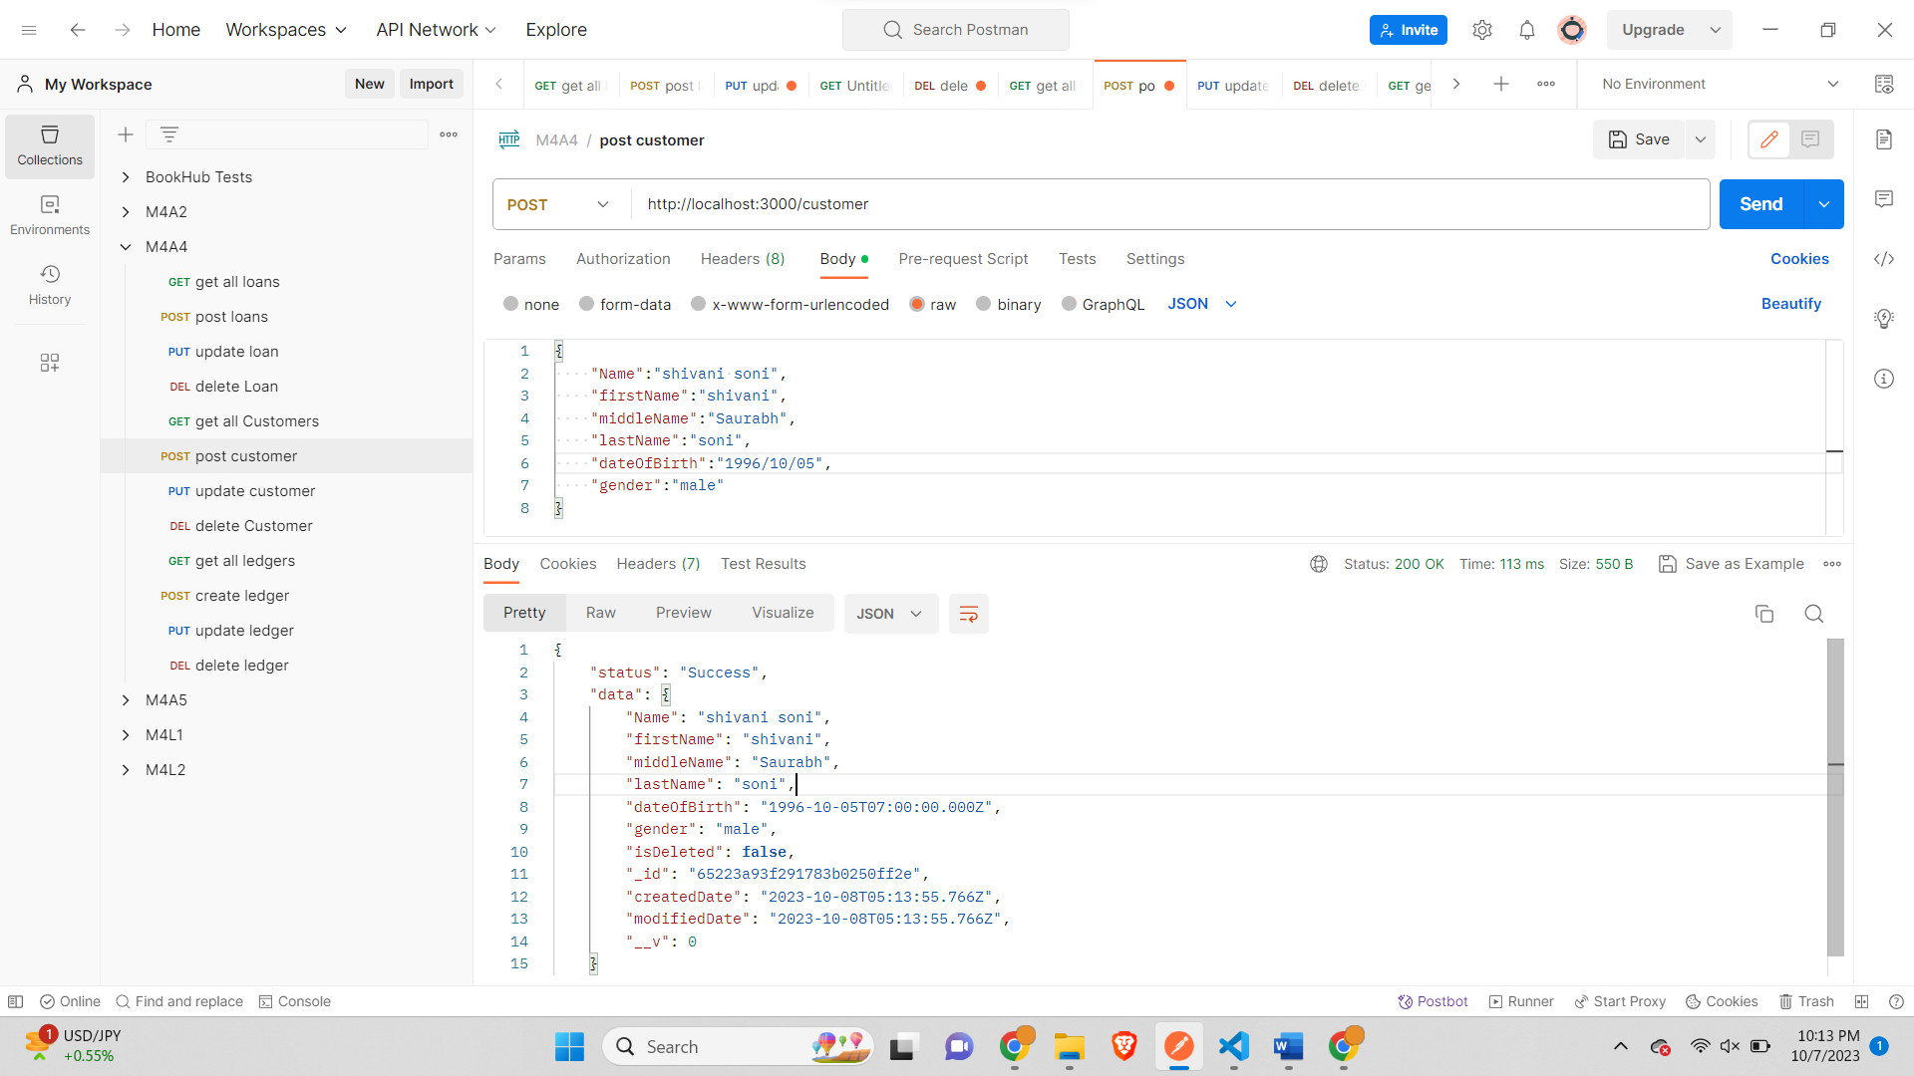

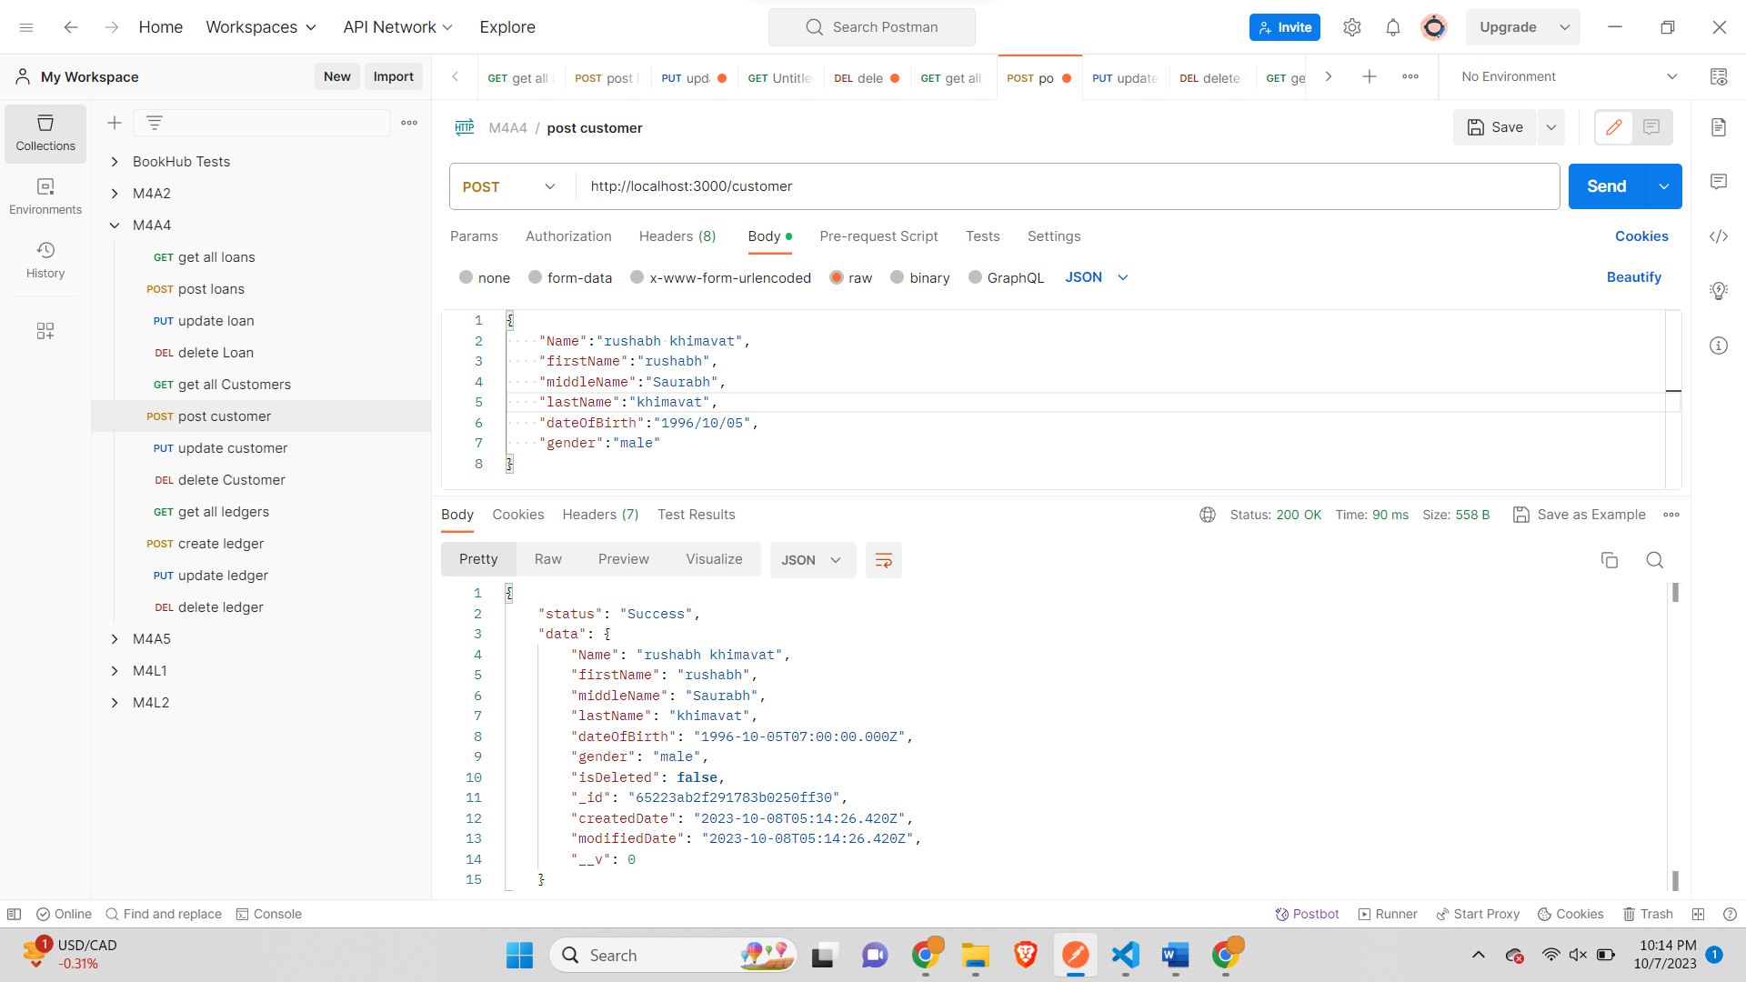

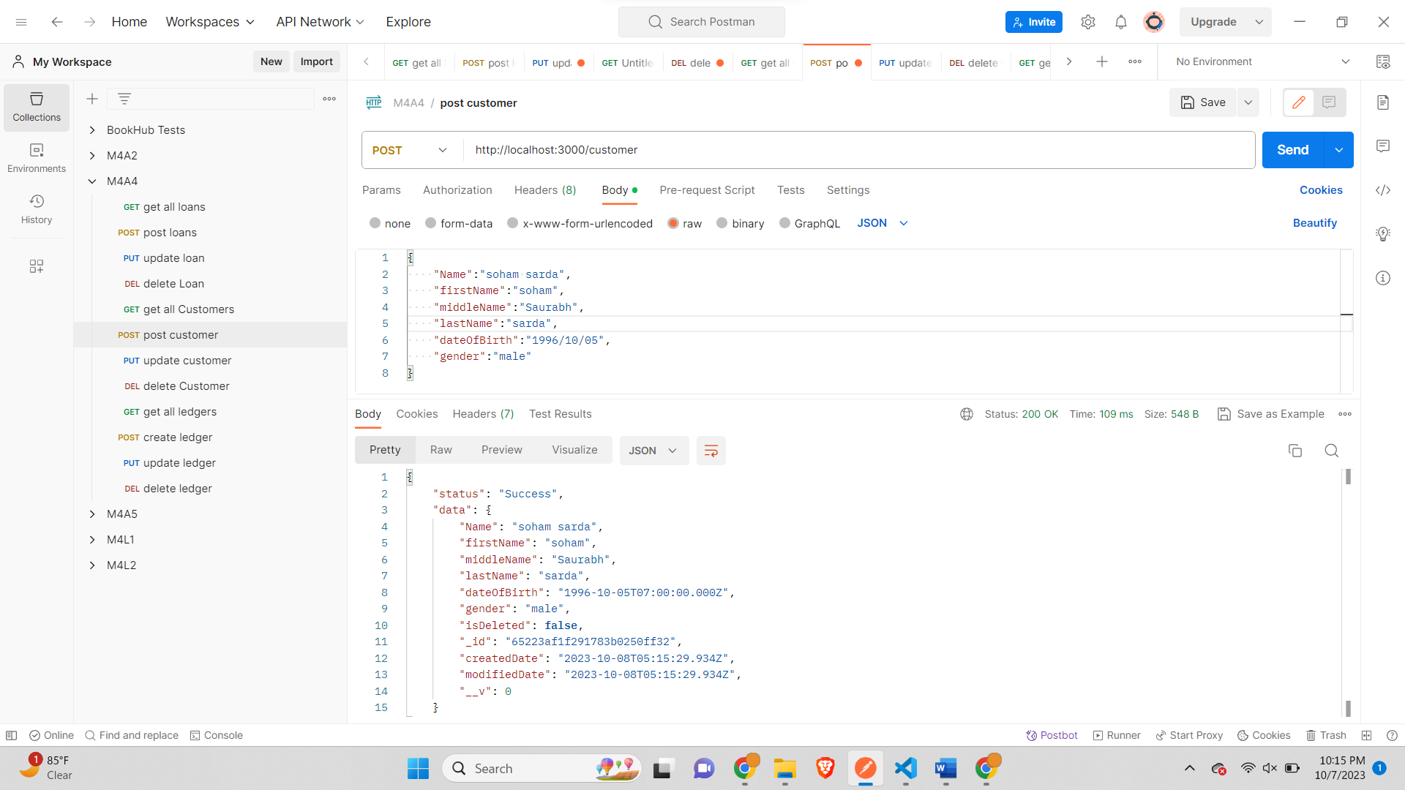

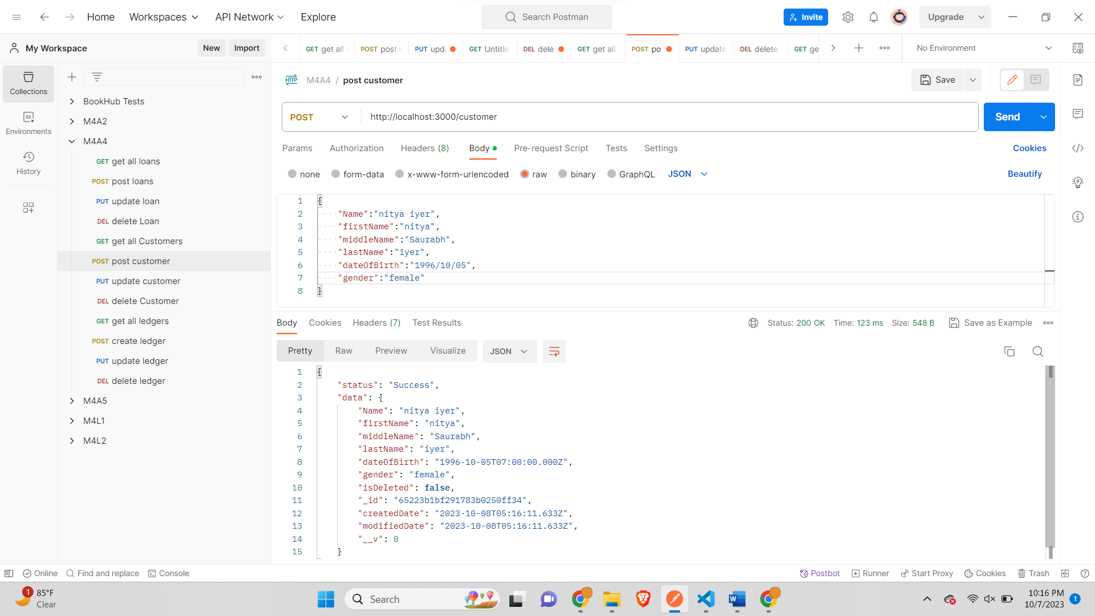

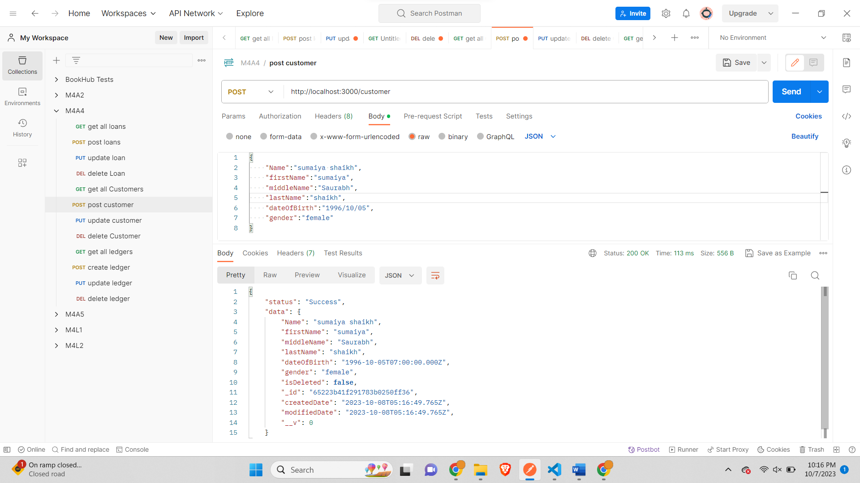

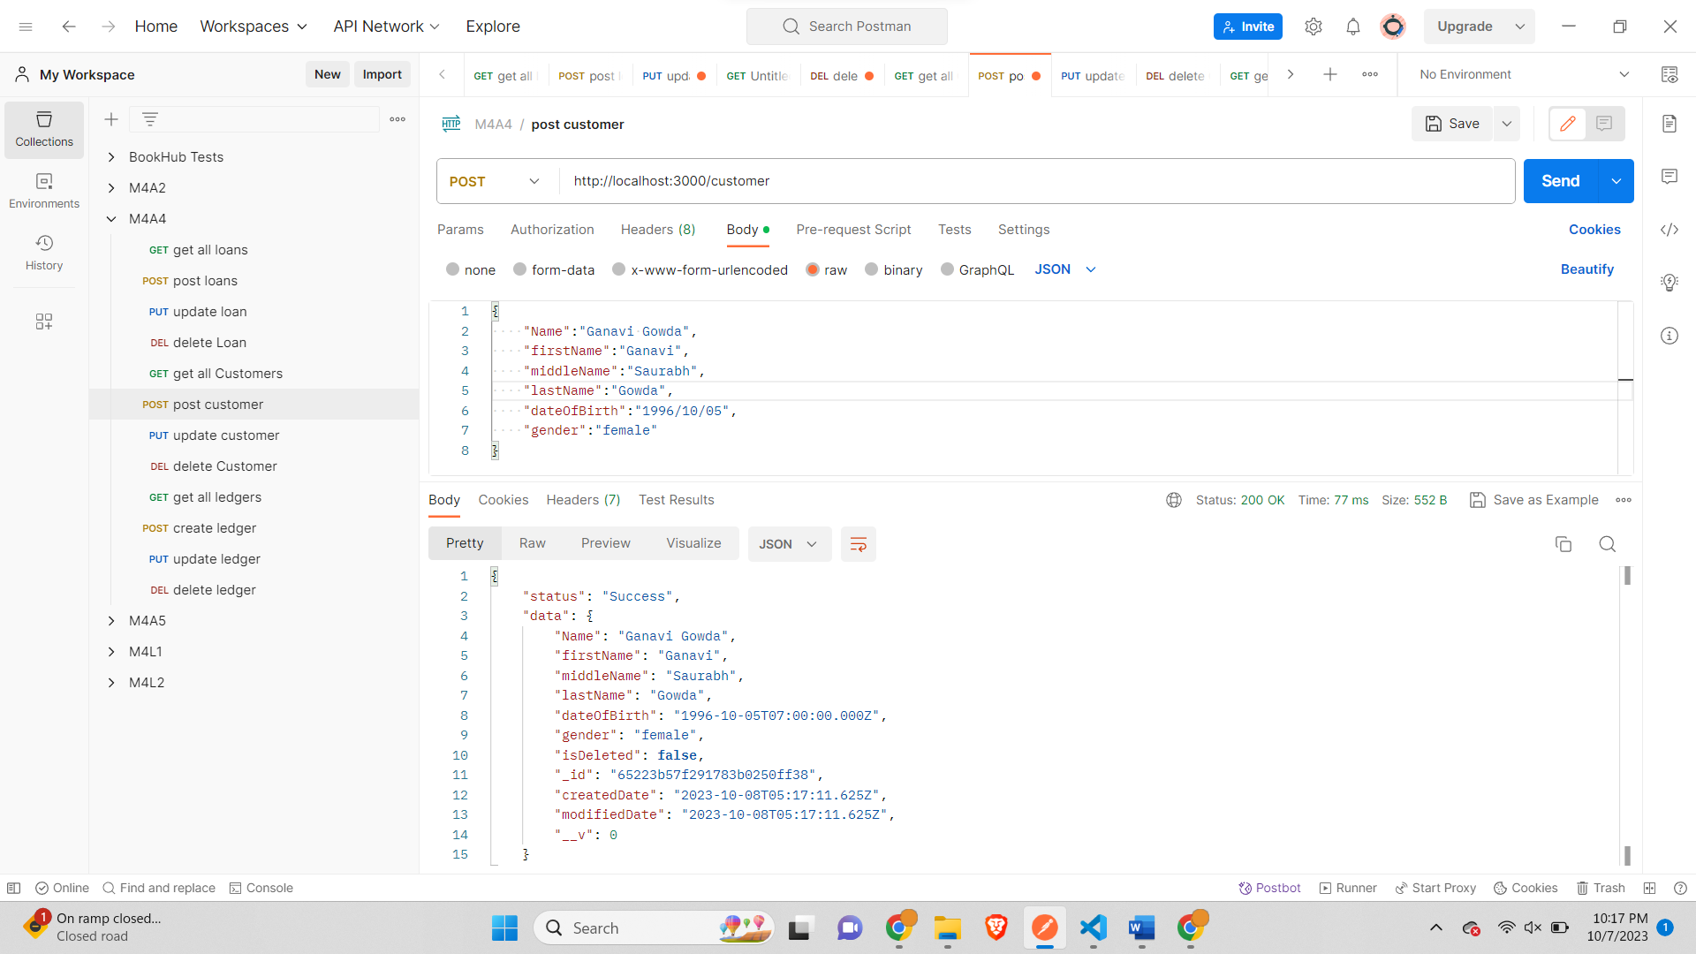

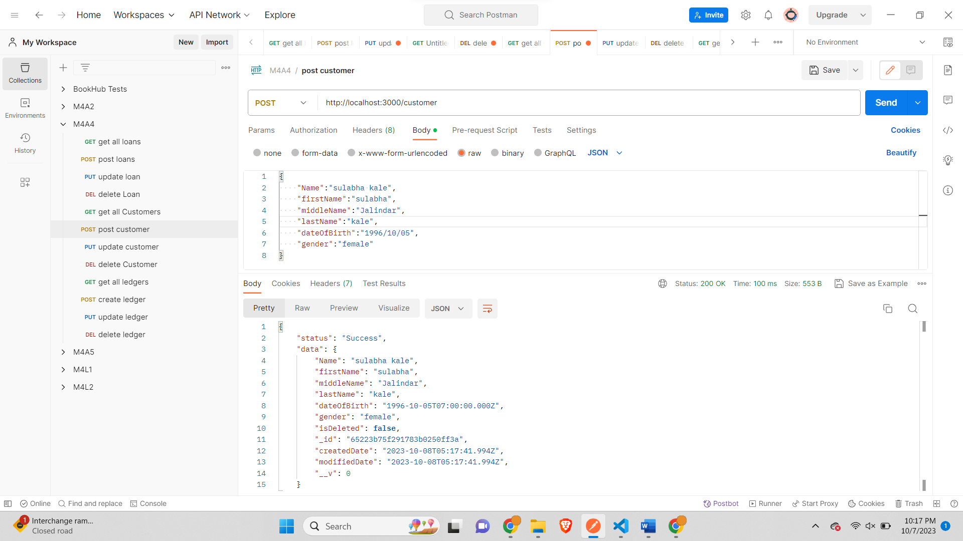

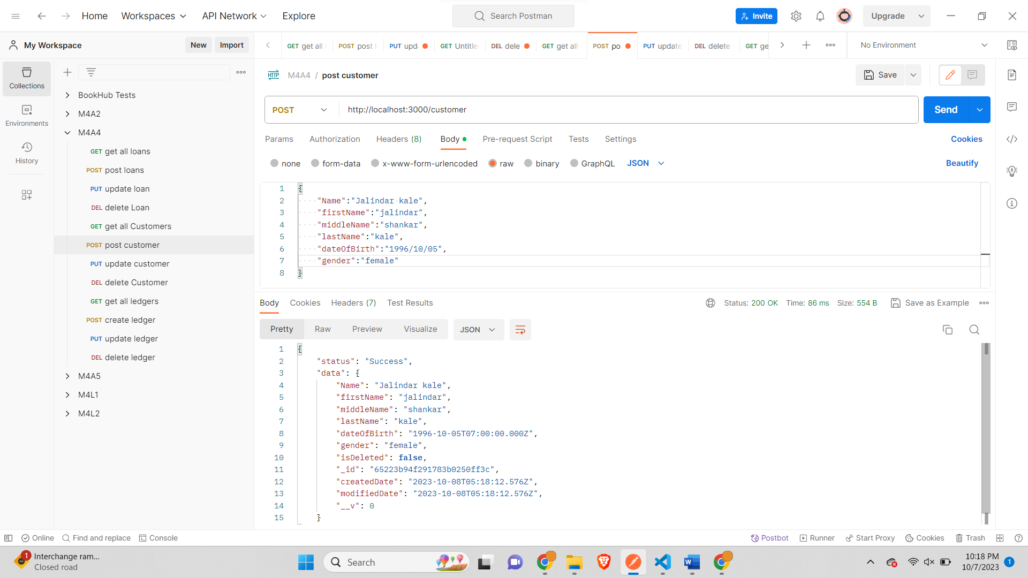

*Insert 3 records of loanTypes-*

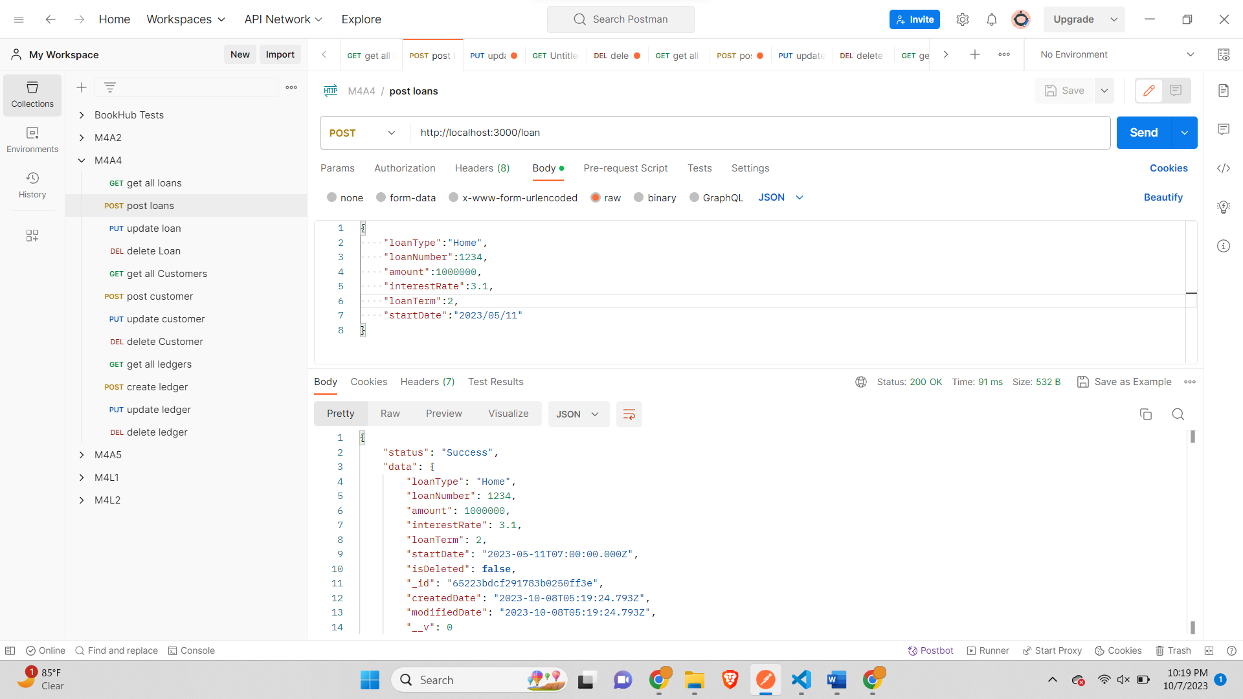

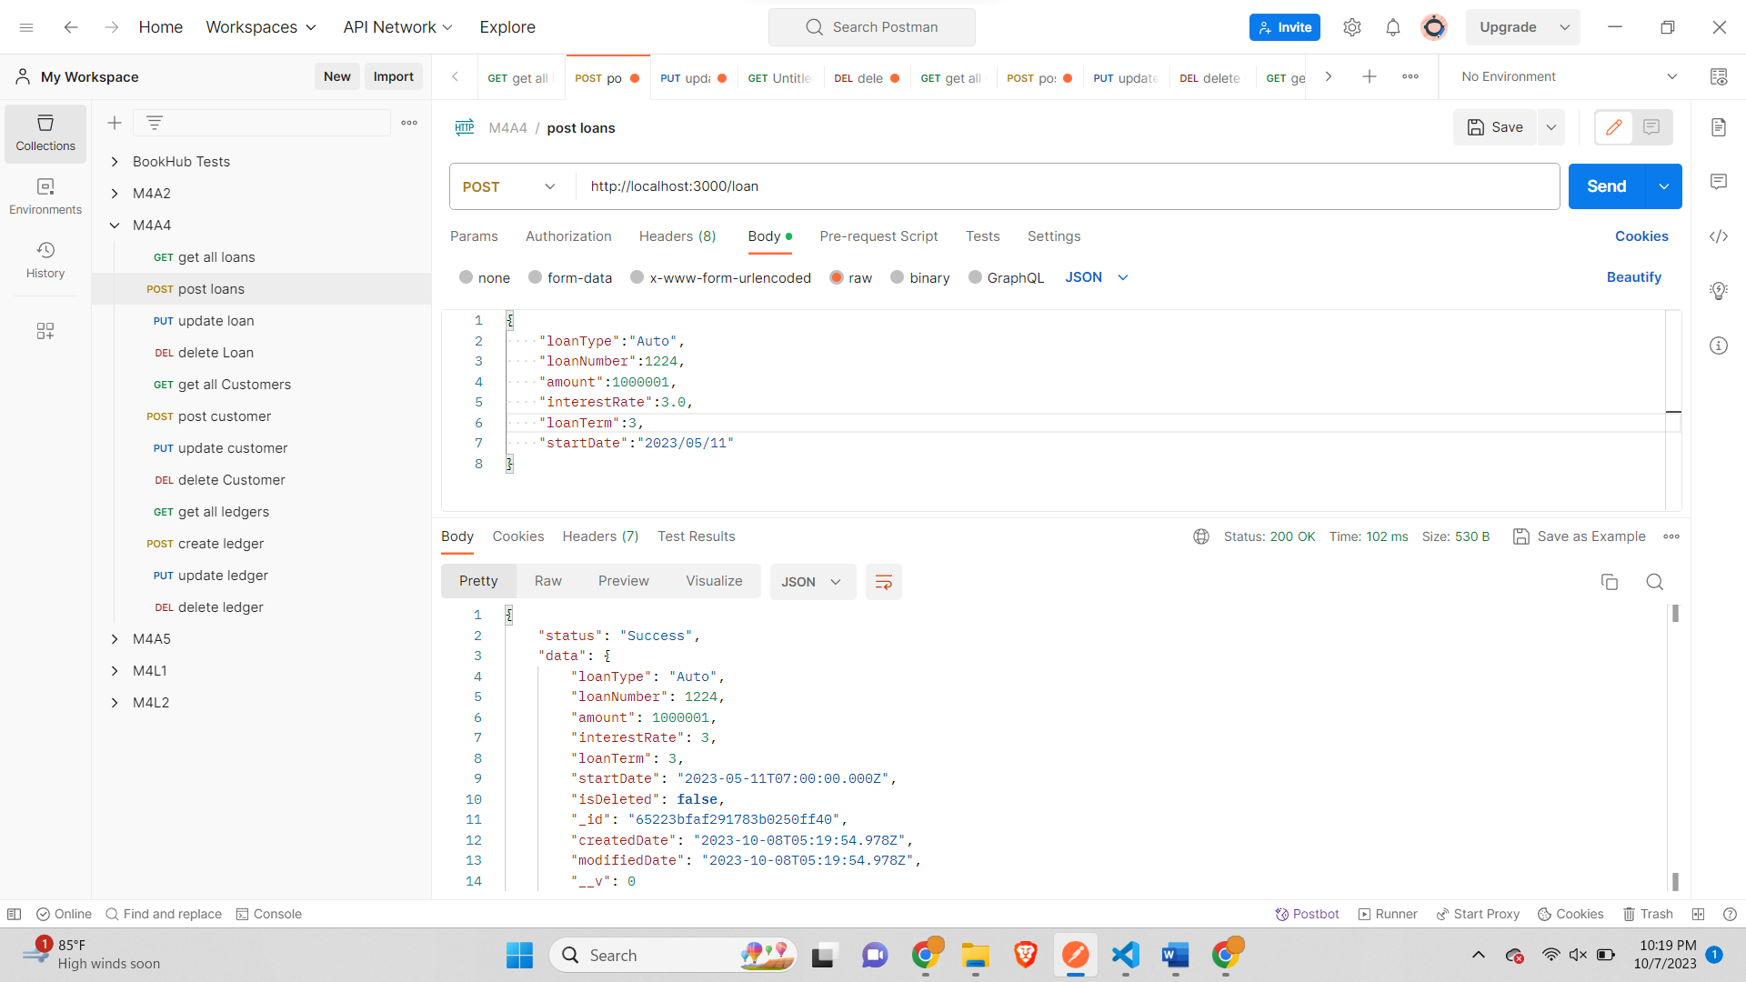

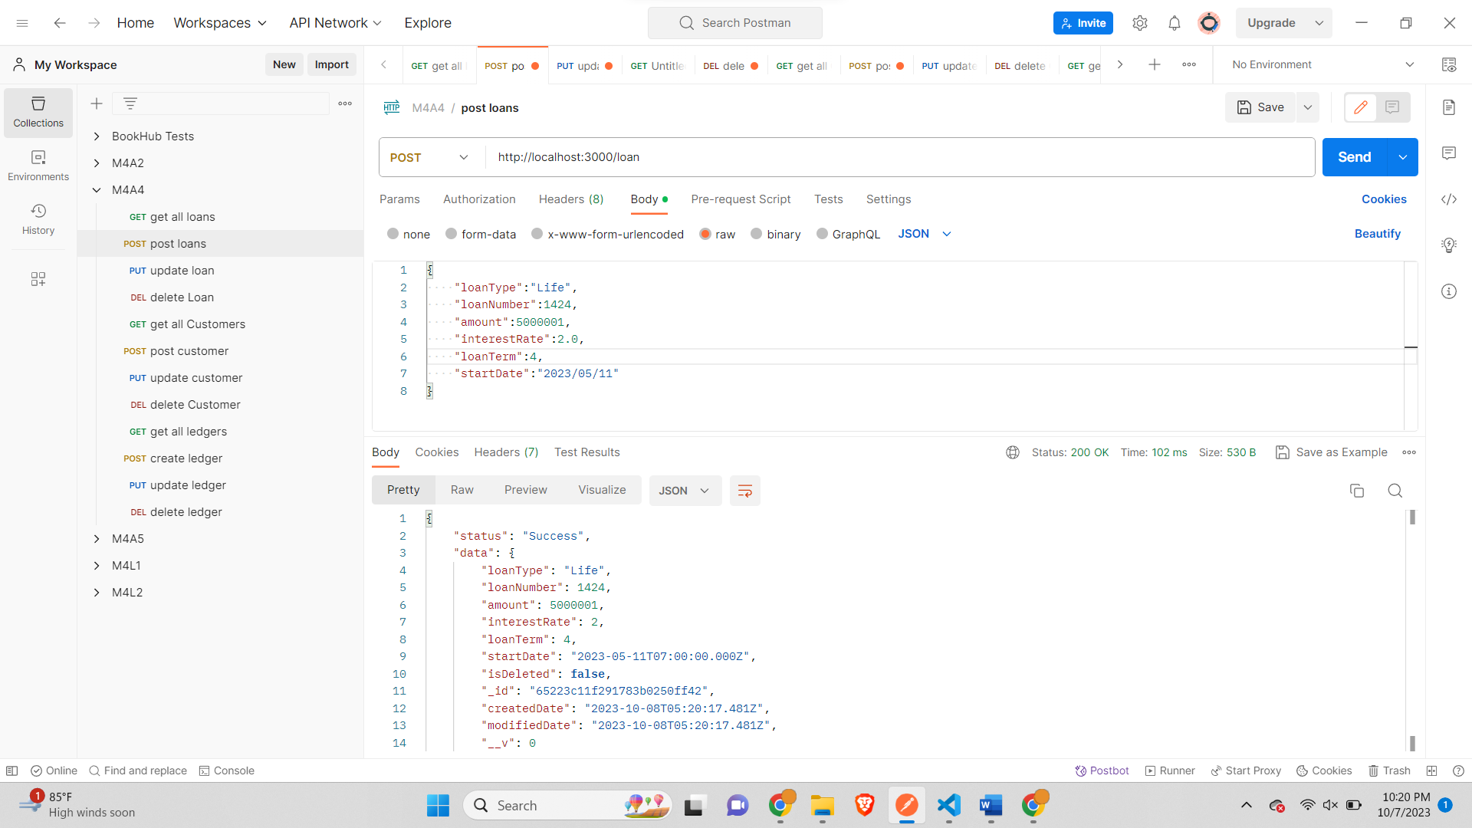

*Insert records for 2 payment type-*

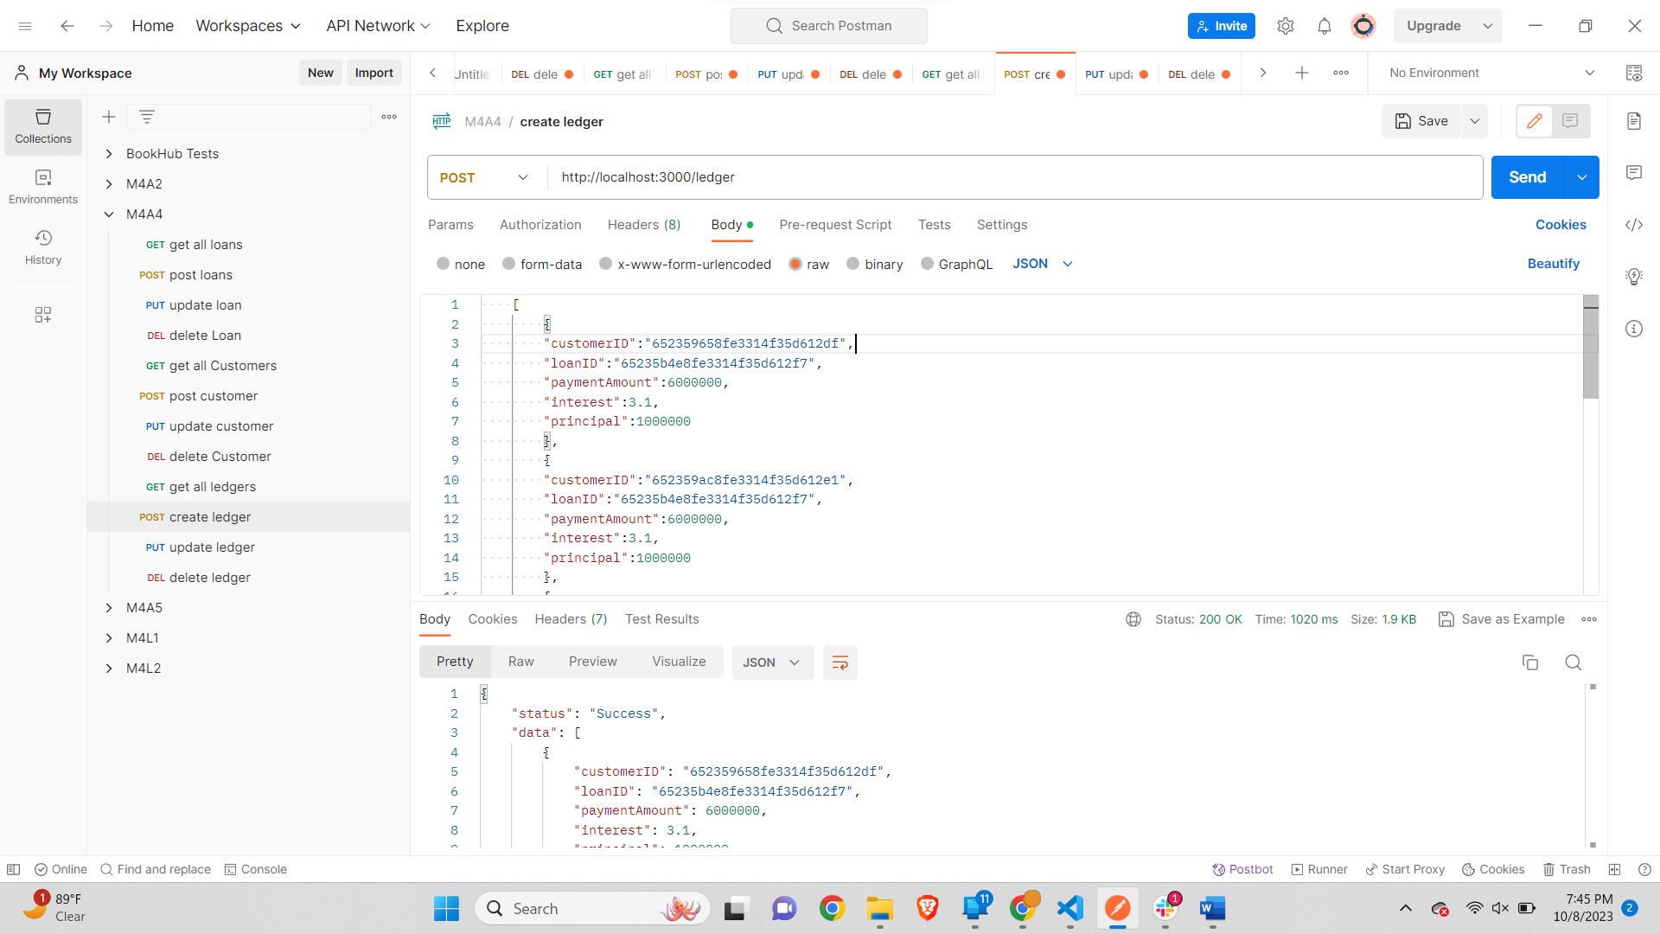

*Body-*

    [

        {

        "customerID":"652359658fe3314f35d612df",

        "loanID":"65235b4e8fe3314f35d612f7",

        "paymentAmount":6000000,

        "interest":3.1,

        "principal":1000000

        },

        {

        "customerID":"652359ac8fe3314f35d612e1",

        "loanID":"65235b4e8fe3314f35d612f7",

        "paymentAmount":6000000,

        "interest":3.1,

        "principal":1000000

        },

        {

        "customerID":"652359b88fe3314f35d612e3",

        "loanID":"65235b4e8fe3314f35d612f7",

        "paymentAmount":6000000,

        "interest":3.1,

        "principal":1000000

        },

        {

        "customerID":"652359e28fe3314f35d612e6",

        "loanID":"65235b4e8fe3314f35d612f7",

        "paymentAmount":6000000,

        "interest":3.1,

        "principal":1000000

        },

        {

        "customerID":"652359f18fe3314f35d612e8",

        "loanID":"65235b4e8fe3314f35d612f7",

        "paymentAmount":6000000,

        "interest":3.1,

        "principal":1000000

        },

        {

        "customerID":"65235a028fe3314f35d612ea",

        "loanID":"65235b4e8fe3314f35d612f7",

        "paymentAmount":6000000,

        "interest":3.1,

        "principal":1000000

        }

    ]

*Output-*

{

    "status": "Success",

    "data": [

        {

            "customerID": "652359658fe3314f35d612df",

            "loanID": "65235b4e8fe3314f35d612f7",

            "paymentAmount": 6000000,

            "interest": 3.1,

            "principal": 1000000,

            "isDeleted": **false**,

            "_id": "652363c9f7745b7976d9b56d",

            "createdDate": "2023-10-09T02:22:01.724Z",

            "modifiedDate": "2023-10-09T02:22:01.724Z",

            "__v": 0

        },

        {

            "customerID": "652359ac8fe3314f35d612e1",

            "loanID": "65235b4e8fe3314f35d612f7",

            "paymentAmount": 6000000,

            "interest": 3.1,

            "principal": 1000000,

            "isDeleted": **false**,

            "_id": "652363c9f7745b7976d9b56e",

            "createdDate": "2023-10-09T02:22:01.726Z",

            "modifiedDate": "2023-10-09T02:22:01.726Z",

            "__v": 0

        },

        {

            "customerID": "652359b88fe3314f35d612e3",

            "loanID": "65235b4e8fe3314f35d612f7",

            "paymentAmount": 6000000,

            "interest": 3.1,

            "principal": 1000000,

            "isDeleted": **false**,

            "_id": "652363c9f7745b7976d9b56f",

            "createdDate": "2023-10-09T02:22:01.726Z",

            "modifiedDate": "2023-10-09T02:22:01.726Z",

            "__v": 0

        },

        {

            "customerID": "652359e28fe3314f35d612e6",

            "loanID": "65235b4e8fe3314f35d612f7",

            "paymentAmount": 6000000,

            "interest": 3.1,

            "principal": 1000000,

            "isDeleted": **false**,

            "_id": "652363c9f7745b7976d9b570",

            "createdDate": "2023-10-09T02:22:01.727Z",

            "modifiedDate": "2023-10-09T02:22:01.727Z",

            "__v": 0

        },

        {

            "customerID": "652359f18fe3314f35d612e8",

            "loanID": "65235b4e8fe3314f35d612f7",

            "paymentAmount": 6000000,

            "interest": 3.1,

            "principal": 1000000,

            "isDeleted": **false**,

            "_id": "652363c9f7745b7976d9b571",

            "createdDate": "2023-10-09T02:22:01.727Z",

            "modifiedDate": "2023-10-09T02:22:01.727Z",

            "__v": 0

        },

        {

            "customerID": "65235a028fe3314f35d612ea",

            "loanID": "65235b4e8fe3314f35d612f7",

            "paymentAmount": 6000000,

            "interest": 3.1,

            "principal": 1000000,

            "isDeleted": **false**,

            "_id": "652363c9f7745b7976d9b572",

            "createdDate": "2023-10-09T02:22:01.728Z",

            "modifiedDate": "2023-10-09T02:22:01.728Z",

            "__v": 0

        }

    ]

}

Second payment-

    [

        {

        "customerID":"65235a028fe3314f35d612ea",

        "loanID":"65235b5c8fe3314f35d612f9",

        "paymentAmount":6000000,

        "interest":3.1,

        "principal":1000000

        },

        {

        "customerID":"65235a308fe3314f35d612ec",

        "loanID":"65235b5c8fe3314f35d612f9",

        "paymentAmount":6000000,

        "interest":3.1,

        "principal":1000000

        },

        {

        "customerID":"65235a7f8fe3314f35d612ef",

        "loanID":"65235b5c8fe3314f35d612f9",

        "paymentAmount":6000000,

        "interest":3.1,

        "principal":1000000

        },

        {

        "customerID":"65235a8f8fe3314f35d612f1",

        "loanID":"65235b5c8fe3314f35d612f9",

        "paymentAmount":6000000,

        "interest":3.1,

        "principal":1000000

        },

        {

        "customerID":"652359f18fe3314f35d612e8",

        "loanID":"65235b5c8fe3314f35d612f9",

        "paymentAmount":6000000,

        "interest":3.1,

        "principal":1000000

        }

    ]

*Output-*  
{

    "status": "Success",

    "data": [

        {

            "customerID": "65235a028fe3314f35d612ea",

            "loanID": "65235b5c8fe3314f35d612f9",

            "paymentAmount": 6000000,

            "interest": 3.1,

            "principal": 1000000,

            "isDeleted": **false**,

            "_id": "65237237f7745b7976d9b579",

            "createdDate": "2023-10-09T03:23:35.663Z",

            "modifiedDate": "2023-10-09T03:23:35.663Z",

            "__v": 0

        },

        {

            "customerID": "65235a308fe3314f35d612ec",

            "loanID": "65235b5c8fe3314f35d612f9",

            "paymentAmount": 6000000,

            "interest": 3.1,

            "principal": 1000000,

            "isDeleted": **false**,

            "_id": "65237237f7745b7976d9b57a",

            "createdDate": "2023-10-09T03:23:35.664Z",

            "modifiedDate": "2023-10-09T03:23:35.664Z",

            "__v": 0

        },

        {

            "customerID": "65235a7f8fe3314f35d612ef",

            "loanID": "65235b5c8fe3314f35d612f9",

            "paymentAmount": 6000000,

            "interest": 3.1,

            "principal": 1000000,

            "isDeleted": **false**,

            "_id": "65237237f7745b7976d9b57b",

            "createdDate": "2023-10-09T03:23:35.665Z",

            "modifiedDate": "2023-10-09T03:23:35.665Z",

            "__v": 0

        },

        {

            "customerID": "65235a8f8fe3314f35d612f1",

            "loanID": "65235b5c8fe3314f35d612f9",

            "paymentAmount": 6000000,

            "interest": 3.1,

            "principal": 1000000,

            "isDeleted": **false**,

            "_id": "65237237f7745b7976d9b57c",

            "createdDate": "2023-10-09T03:23:35.666Z",

            "modifiedDate": "2023-10-09T03:23:35.666Z",

            "__v": 0

        },

        {

            "customerID": "652359f18fe3314f35d612e8",

            "loanID": "65235b5c8fe3314f35d612f9",

            "paymentAmount": 6000000,

            "interest": 3.1,

            "principal": 1000000,

            "isDeleted": **false**,

            "_id": "65237237f7745b7976d9b57d",

            "createdDate": "2023-10-09T03:23:35.666Z",

            "modifiedDate": "2023-10-09T03:23:35.666Z",

            "__v": 0

        }

    ]

}

**Part 3: Requirement Storage Design Implementation: (DATABASE)  and**

**Part 4: Use POSTMAN as a client application to test your App server and the Middleware.**

*GET all Loans-*

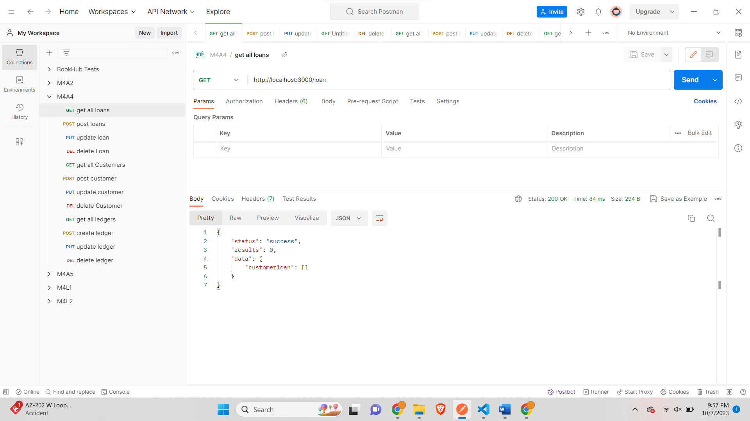

*POST Loan-*

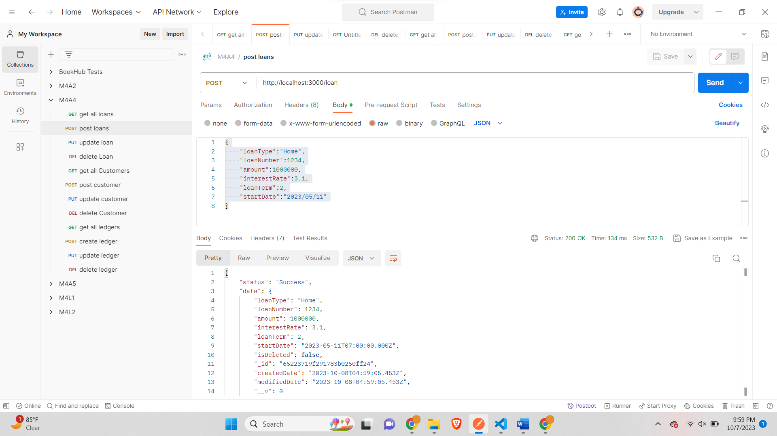

*PUT Loan-*

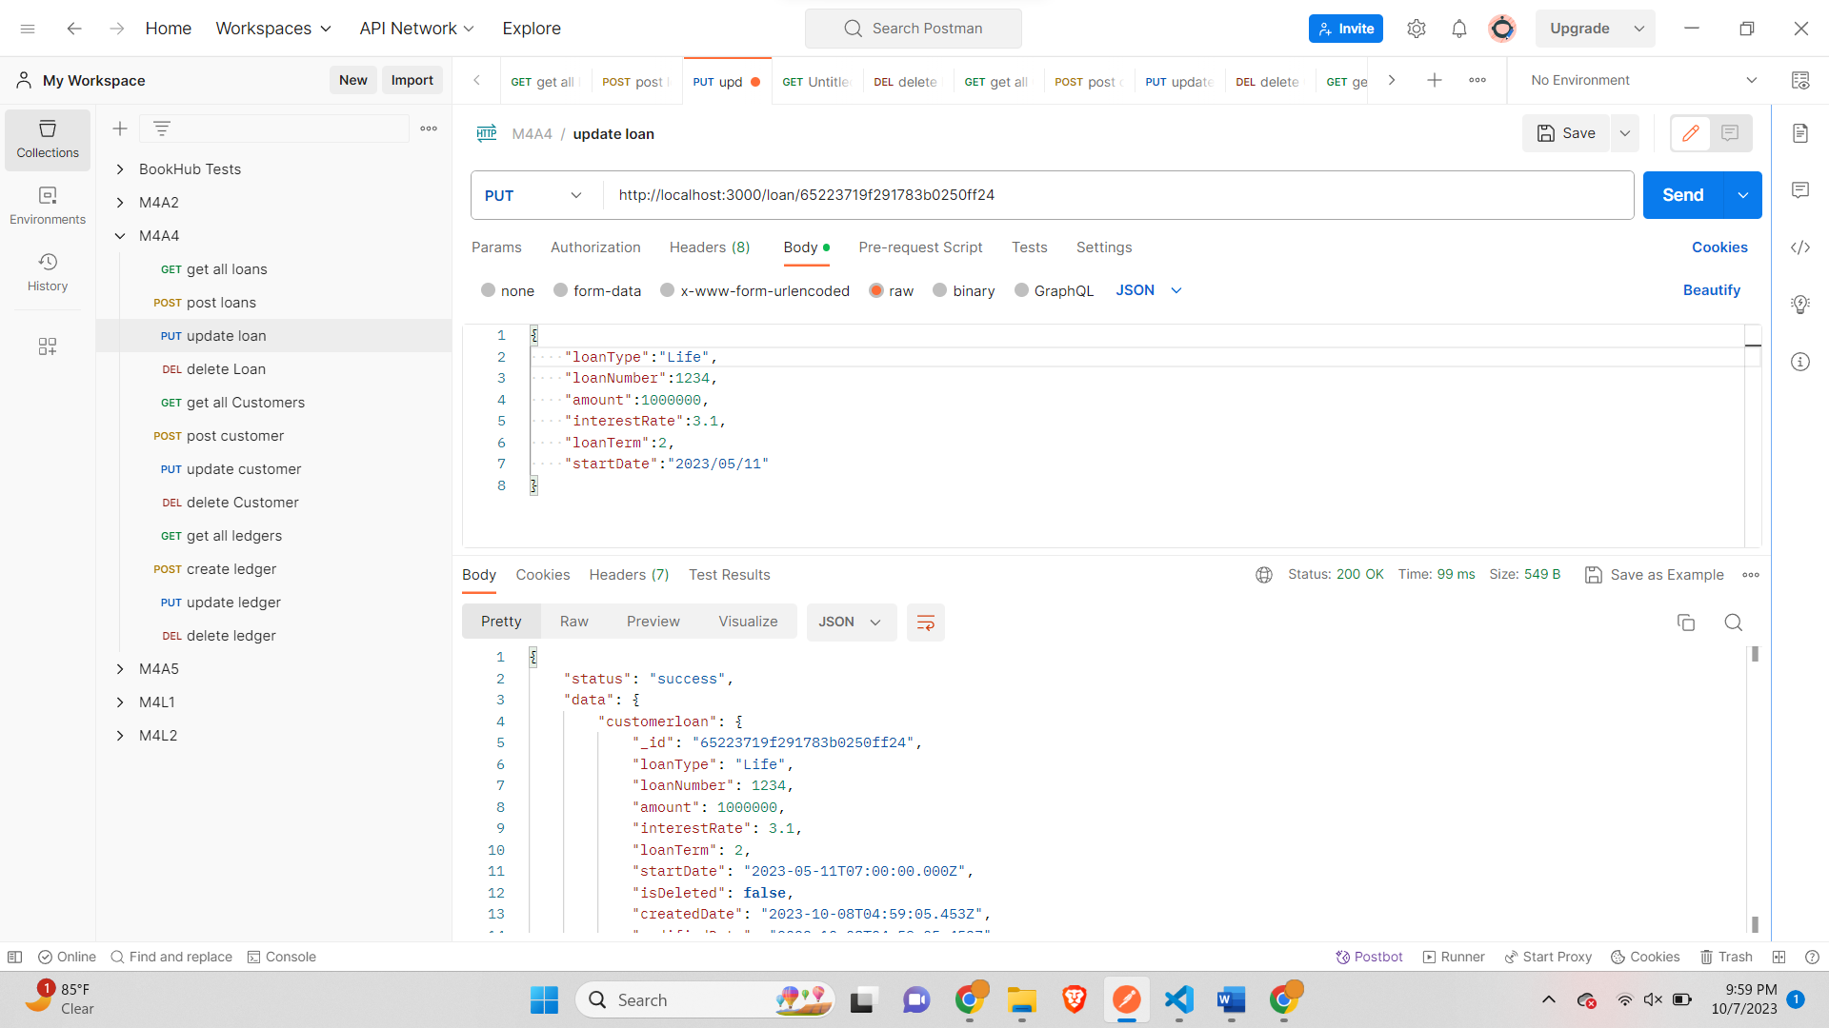

*Delete Loan-*

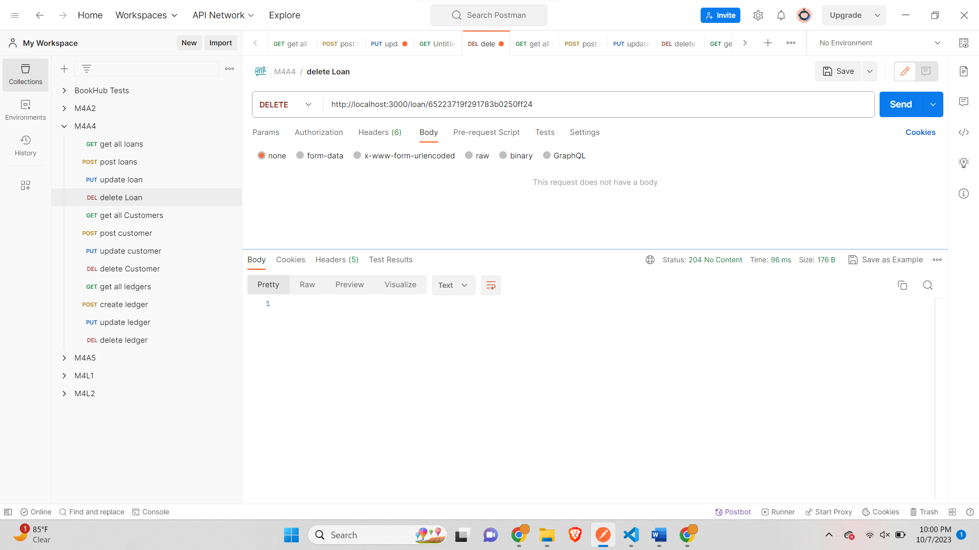

*GET all customers-*

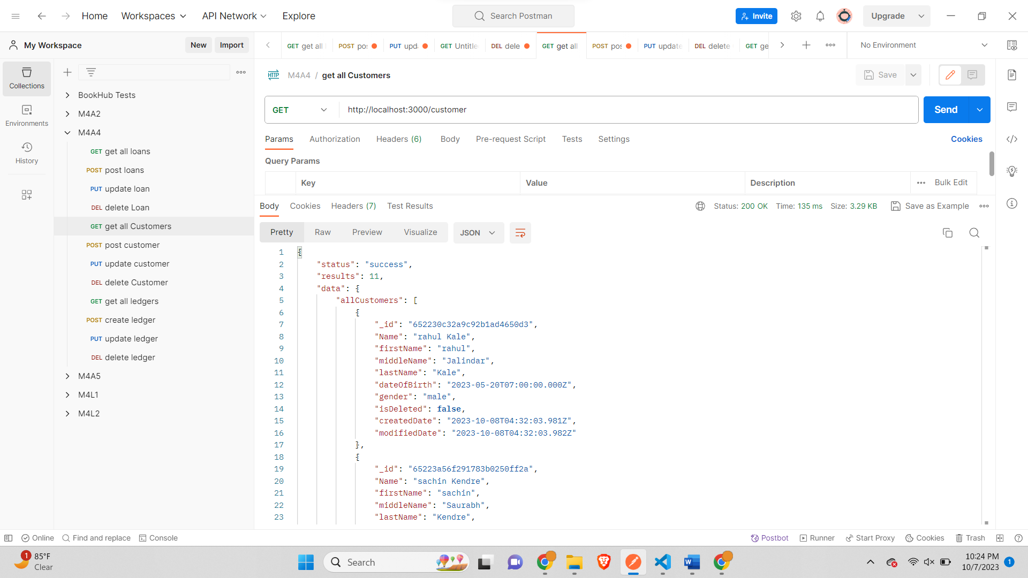

*Post Customer-*

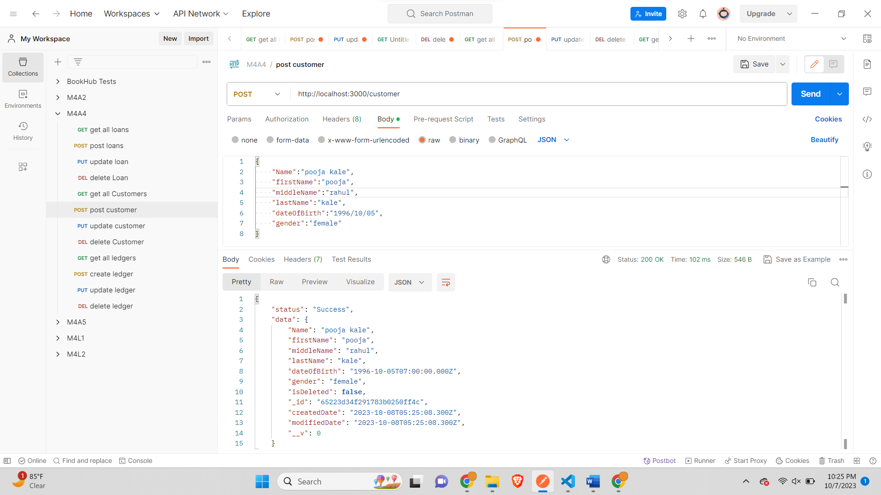

*PUT customer-*

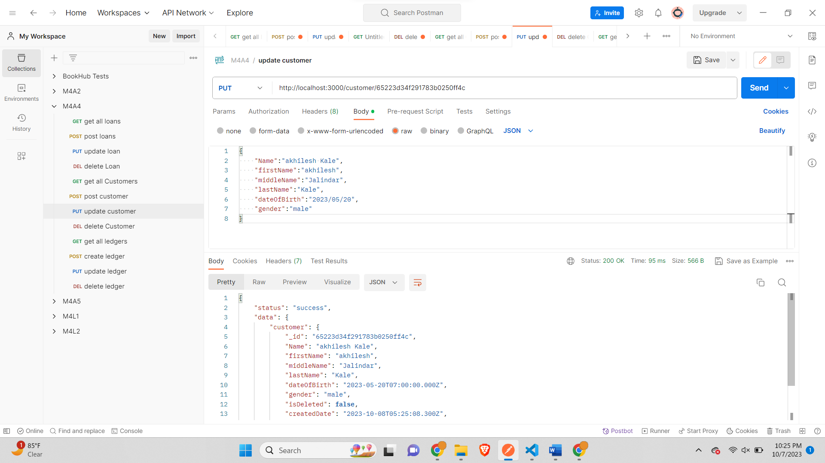

*Delete Customer-*

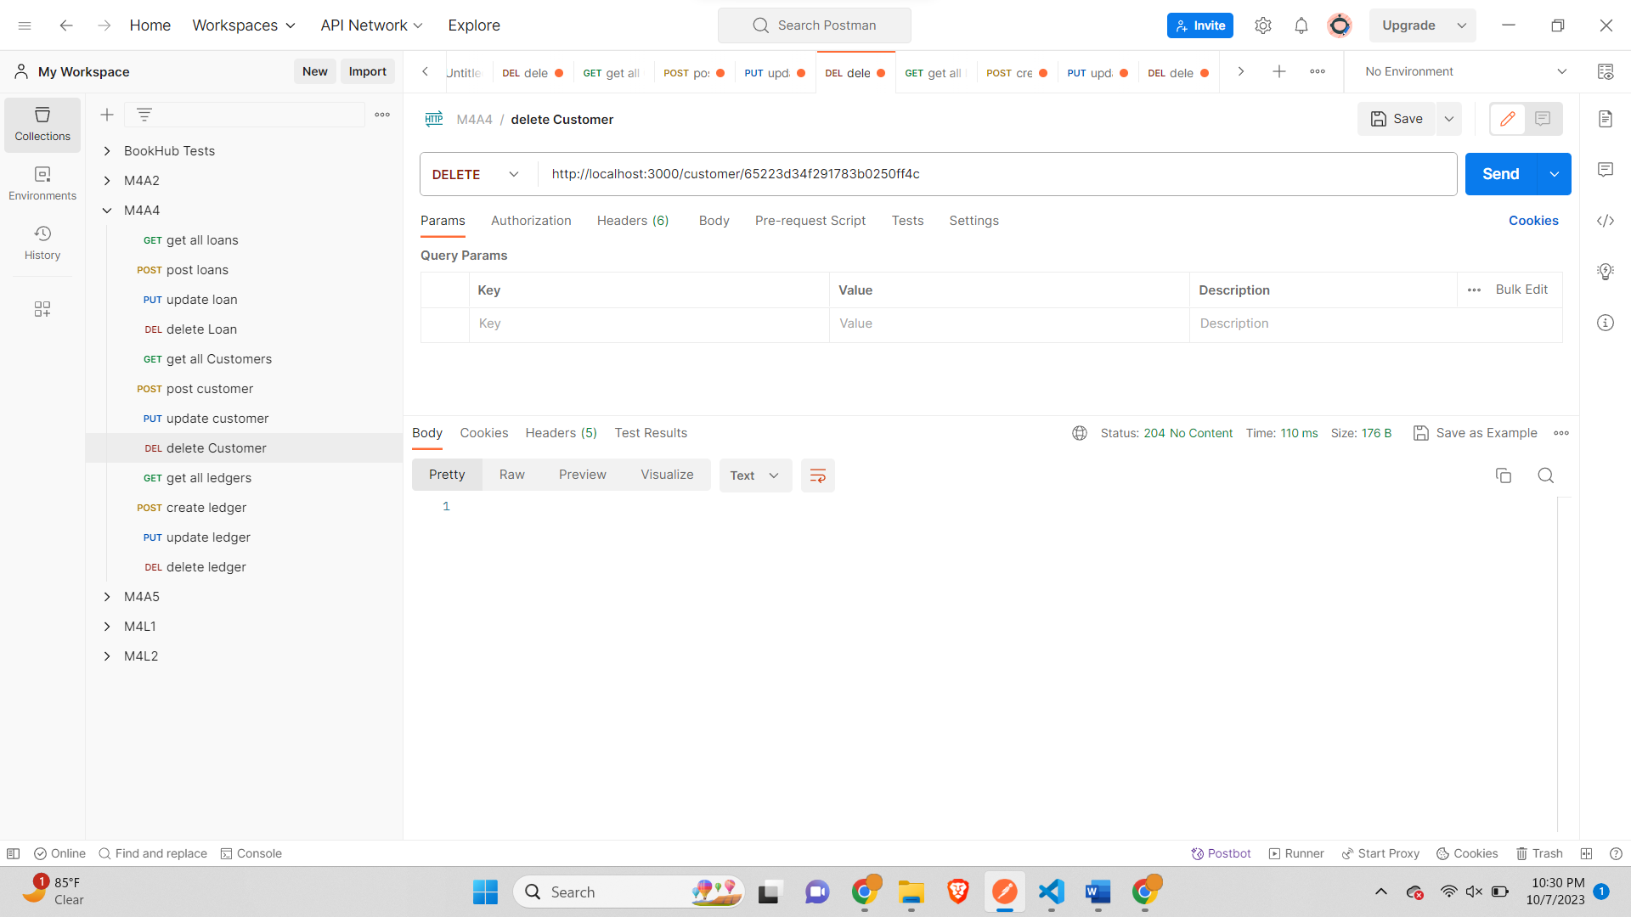

*GET 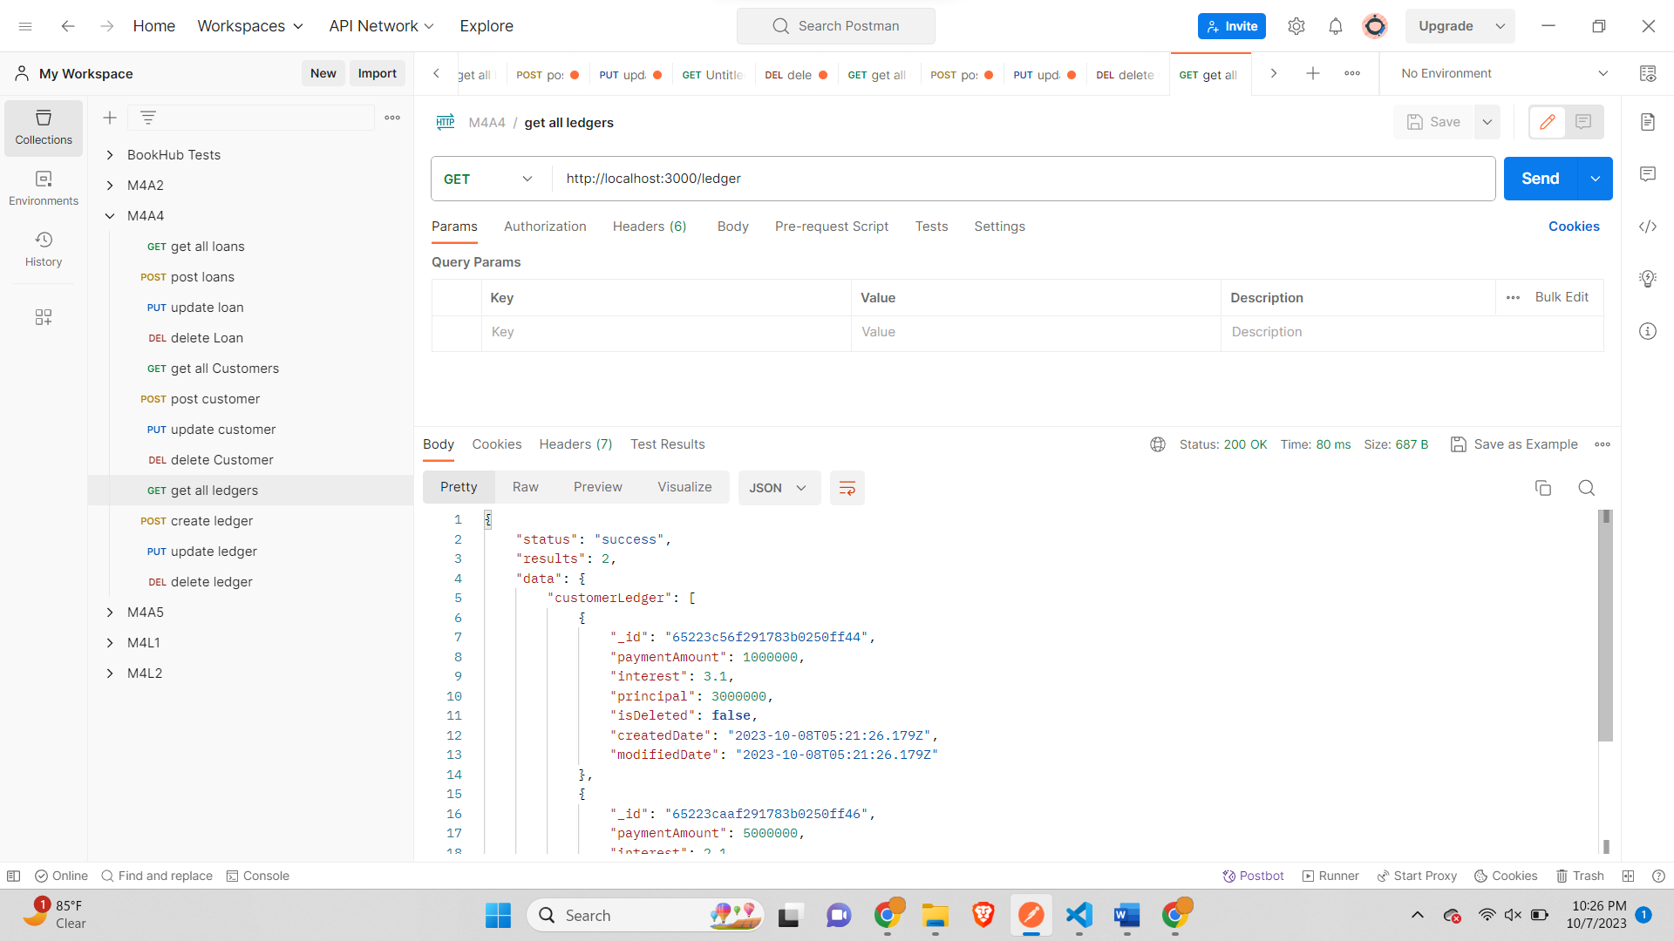*

*POST Ledger-*

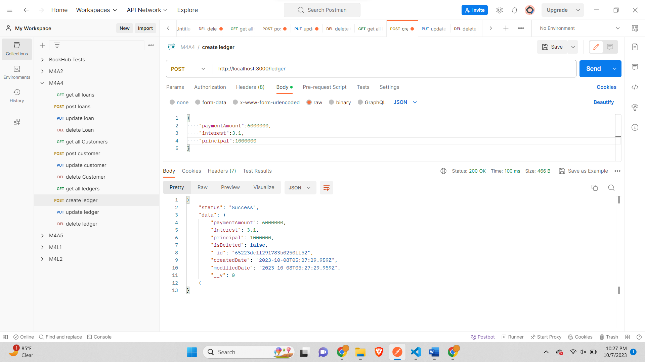

*PUT ledger-*

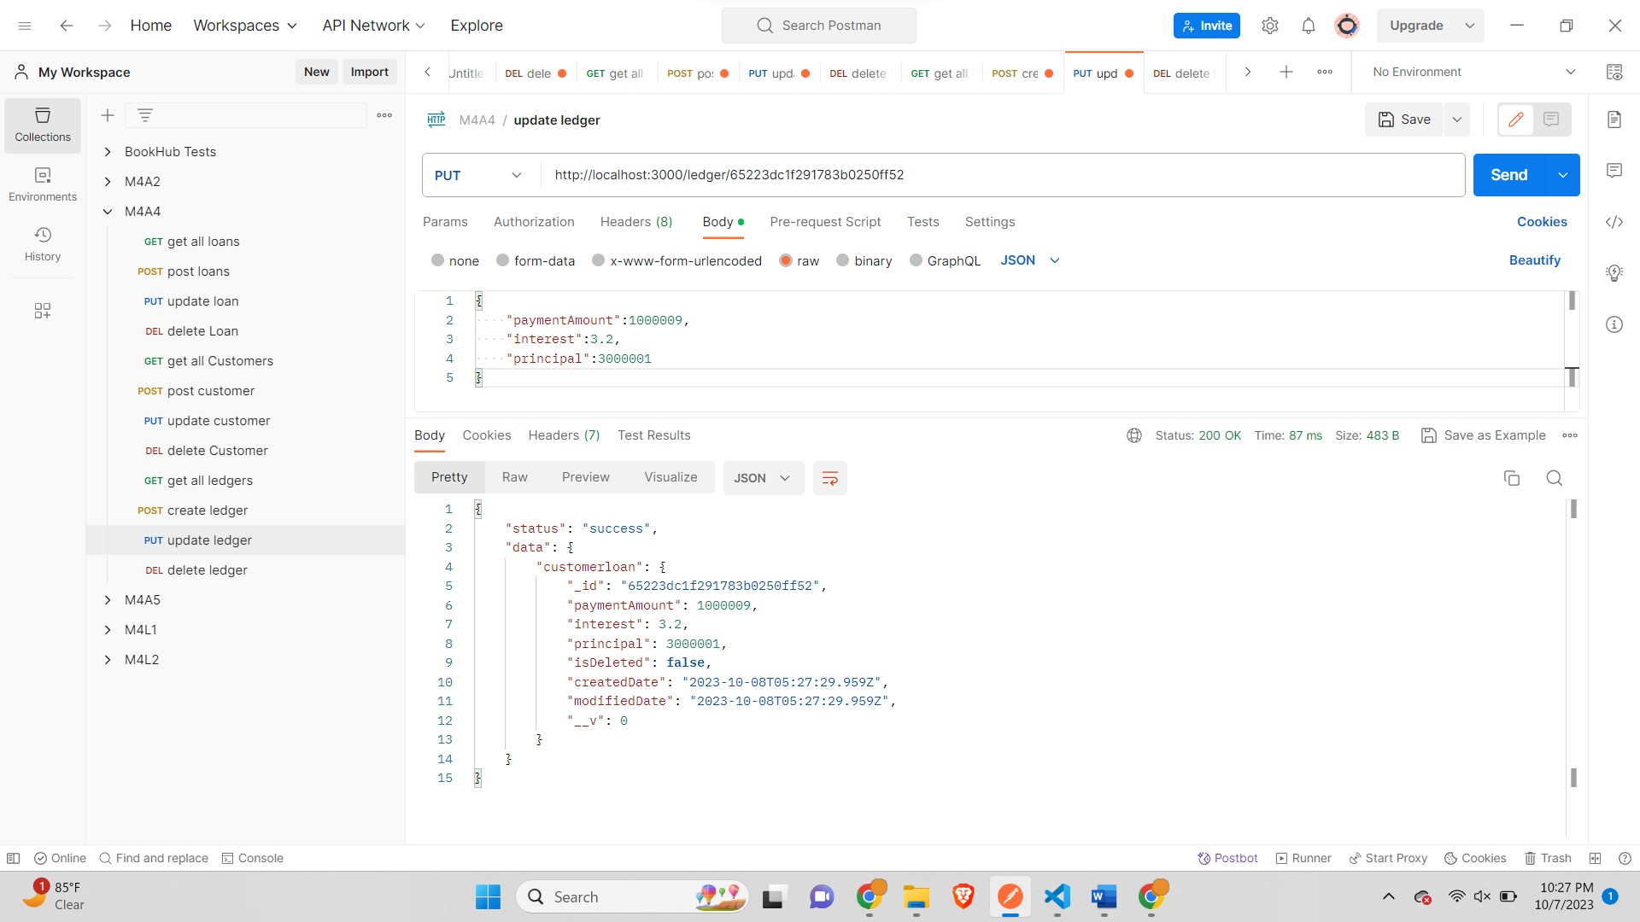

*DELETE Ledger-*

